PROJECT-1

Building a CI/CD Pipeline for a Retail Company

Name: Srinivas Boga

Email: [srinivas.boga@gmail.com](mailto:srinivas.boga@gmail.com)

Mobile: 7659009991

Github: srinivas30240

**Task 1: Clone the project from the GitHub link shared in resources to your local machine. Build the code using Maven commands.**

**Approach i have followed:**

- As a given project is based on java I have used maven as a build tool to build the code.

Maven and java are installed already in the master machine. I have run the maven Compile, test, and package tasks successfully in the local environment and produced the results for each and also executed the maven clean install command to build the code.

Before this I have downloaded the sample Java code from the LMS into my own local environment and used git bash to upload to the below newly created public github repository and also I have uploaded all the code that I have developed to do this project in this repository and all the important files are kept within the directory

Github repository:

<https://github.com/srinivas30240/Final_Edureka_project.git>

- And executed the below tasks of maven in edureka local environment.

**1. /opt/maven/bin/mvn compile**

**2. /opt/maven/bin/mvn test**

**3. /opt/maven/bin/mvn package**

**4. /opt/maven/bin/mvn clean install**

**- /opt/maven/bin/mvn - Is the path of the maven executable.**

1) /opt/maven/bin/mvn compile: Compiles source code of the project

2) /opt/maven/bin/mvn test: Runs tests for the project.

3) /opt/maven/bin/mvn package: Creates WAR file for the project to convert it into a

Distributable format.

4) /opt/maven/bin/mvn clean install: Using the clean command, which will delete all?

Previously compiled Java .class files and resources (like .properties) in the project. Build will

Start from a clean slate.

- Install will then compile, test & package my Java project and even install/copy my built

.war file into my local Maven repository.

- Below are the snapshots of results that I did in the **edureka** provided Lab terminal.

**Compile task running in local:** 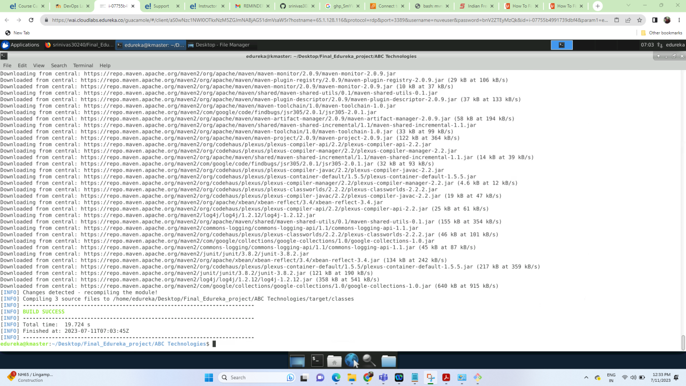

**Test task running in local:**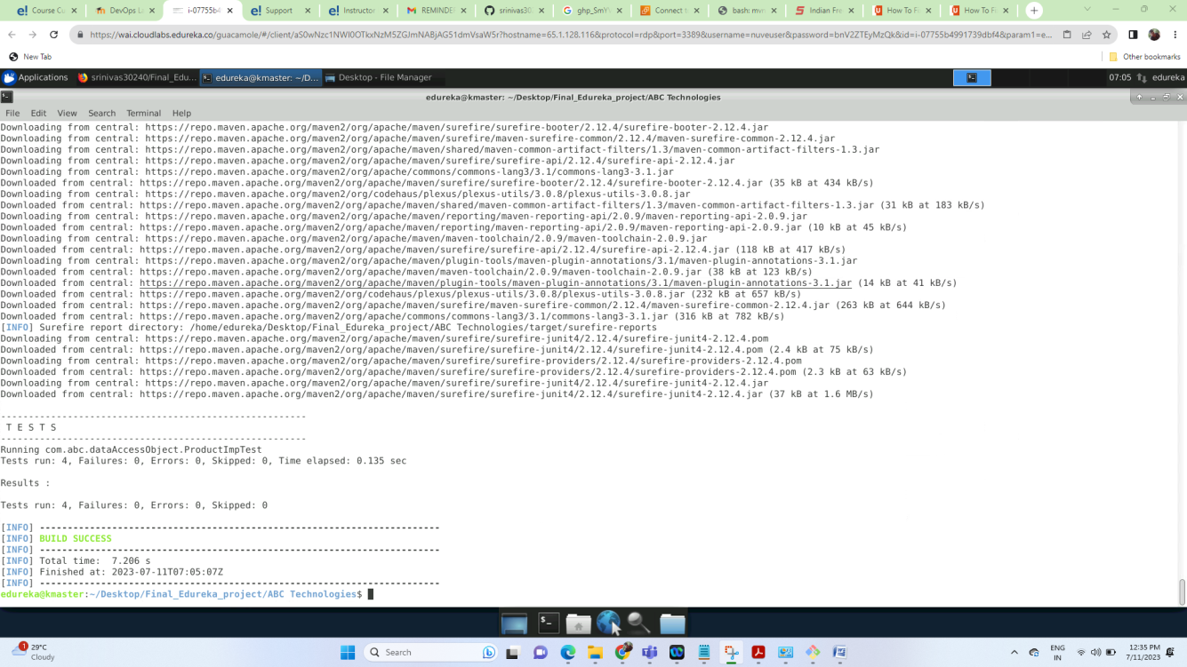

**Package task running in local:**

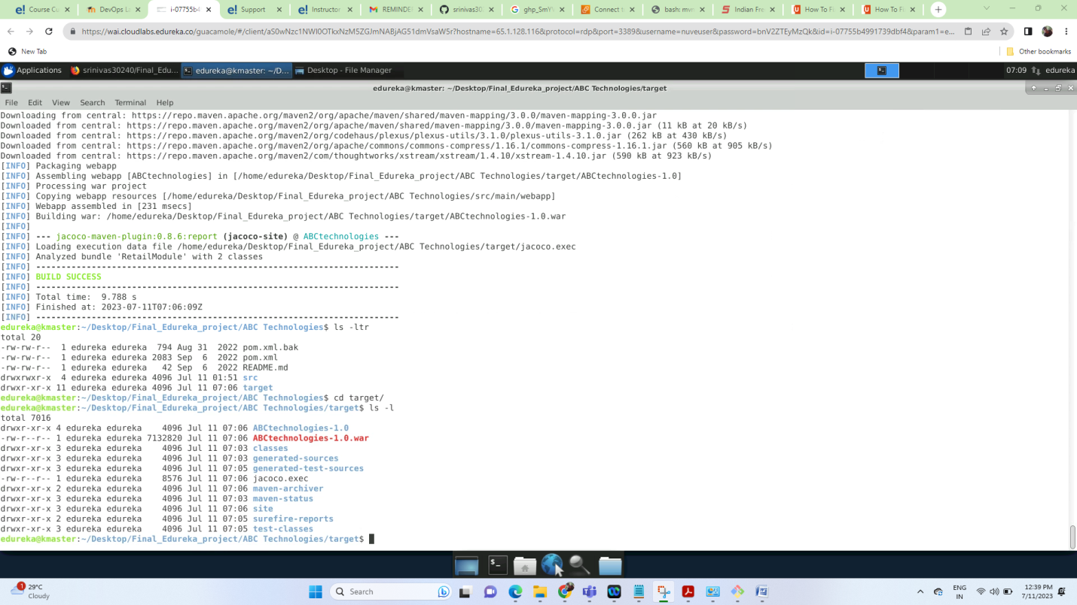

**Clean $ install task running in local:**

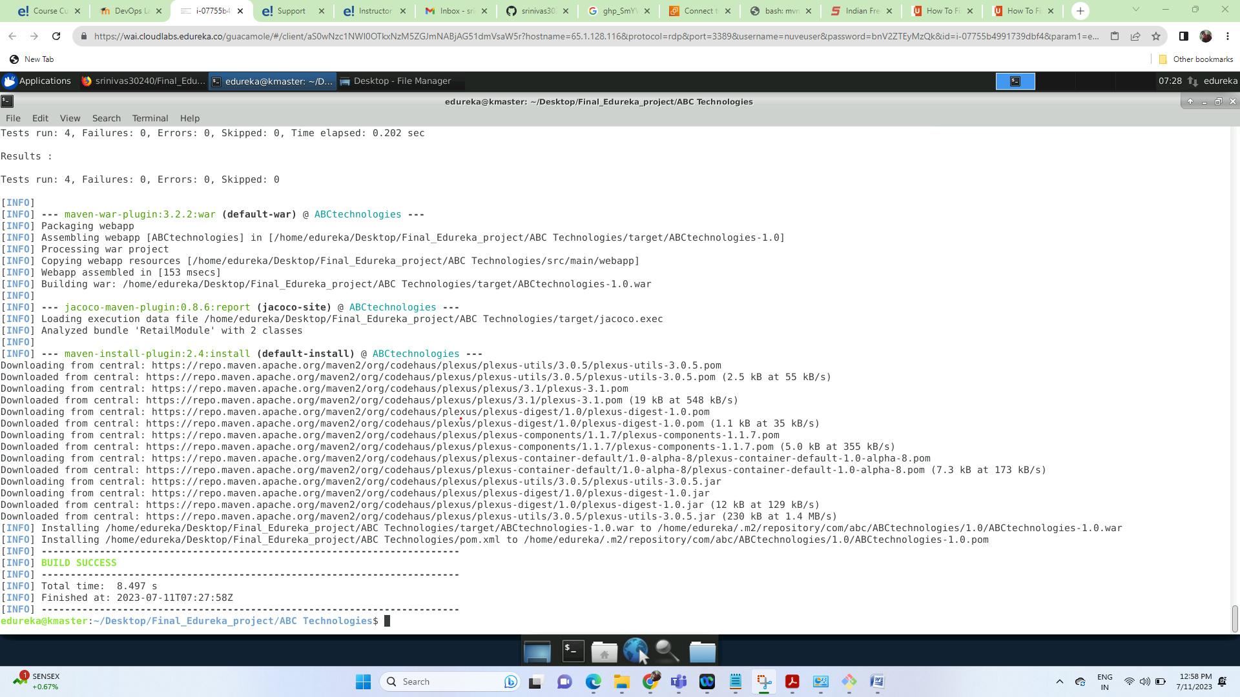

**History and target folder after the maven tasks completed:**

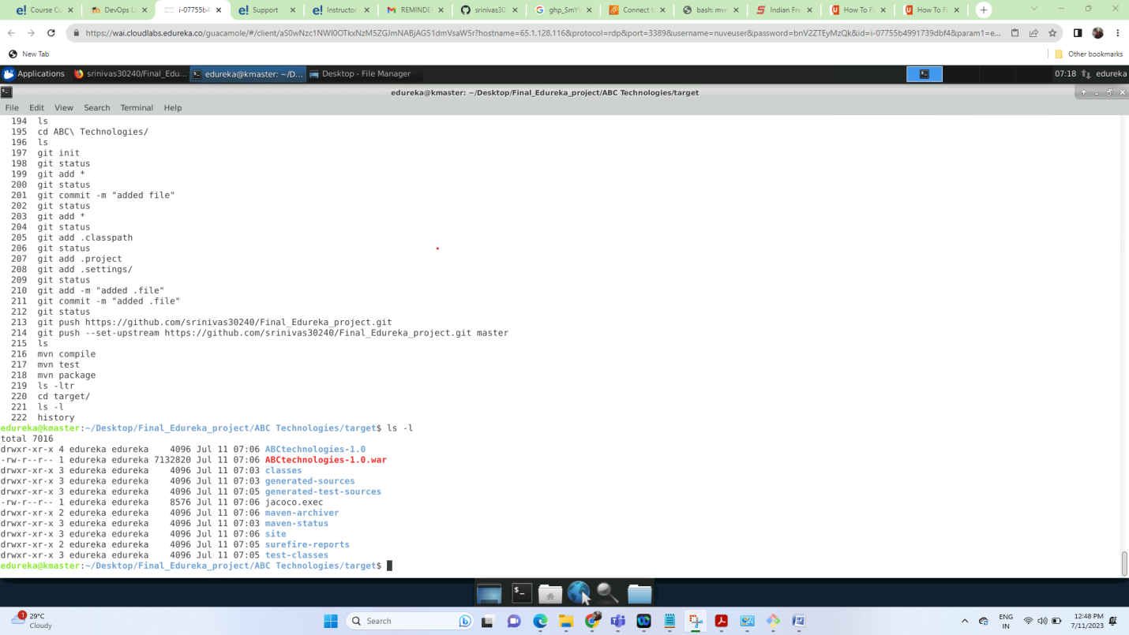

Task 2: Set up the Git repository and push the source code. Then, log in to Jenkins.

2. Create a build pipeline containing a job for each

● One for compiling source code

● Second for testing source code

● Third for packing the code

2. Execute the CI/CD pipeline to execute the jobs created in step 1

3. Set up a master-slave node to distribute the tasks in the pipeline

Approach i have followed:

- Jenkins has been installed in master server already so i have created the 3 jobs for

Compile, test, package in Jenkins and created pipeline with these 3 jobs and set up the agent

Machine(slave machine) and shared the load to agent as well.

- As a given project is based on java i have used maven to build the code and Jenkins is a Build automation server that helps to automate these things so i have set up the java, maven paths of master in global tool configuration in Jenkins and set up the Jenkins goals and left git

Path as default.

- Tools location:

/opt/maven

/usr/lib/jvm/java-8-oracle

- Goals:

Compile

Test

Package

Please find the screenshots of the above task-2:

Jenkins

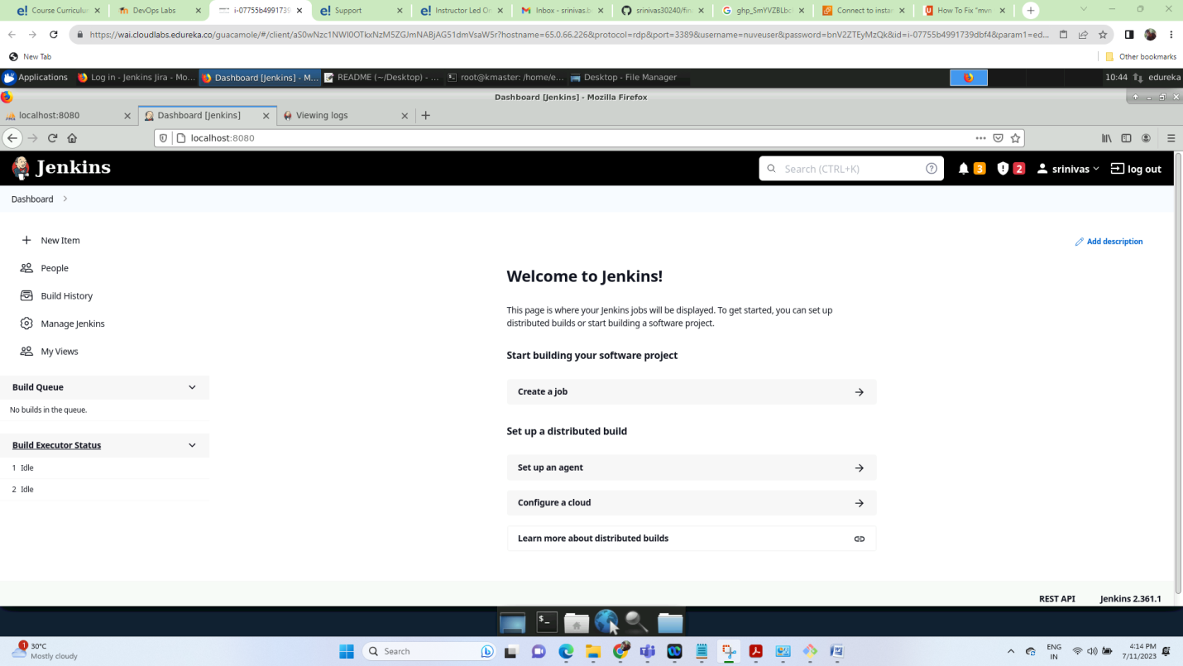

Global tool configuration:

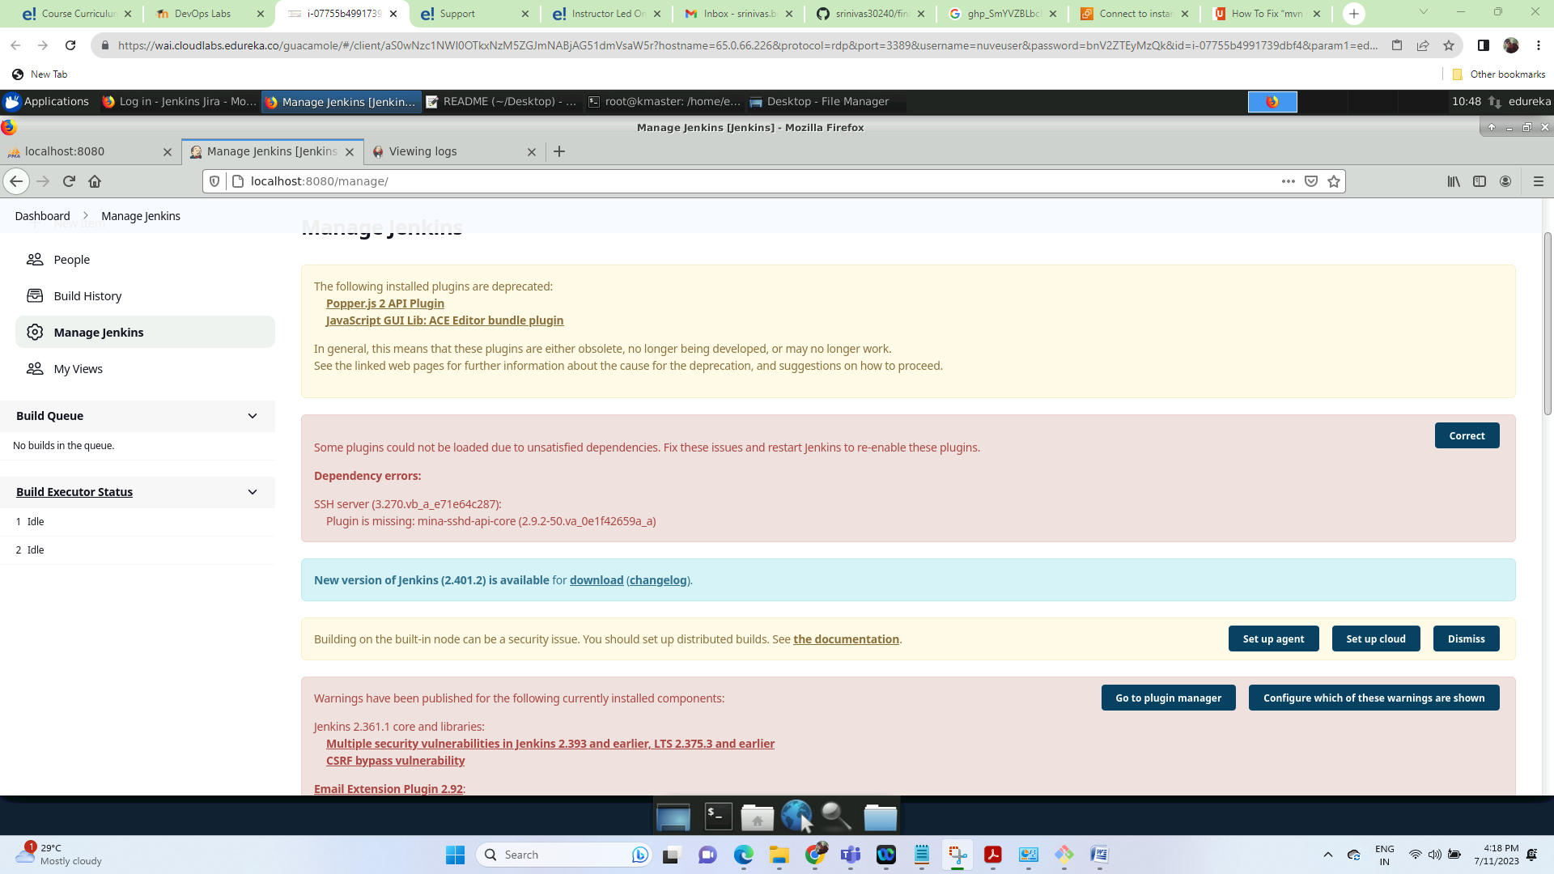

Tool location configuration for java:

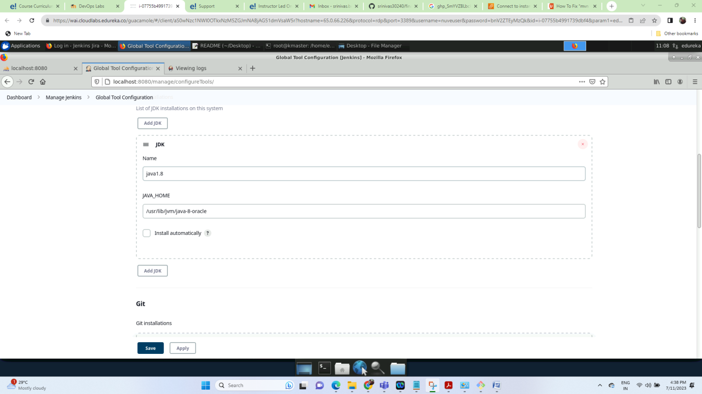

Tool location configuration for git as default:

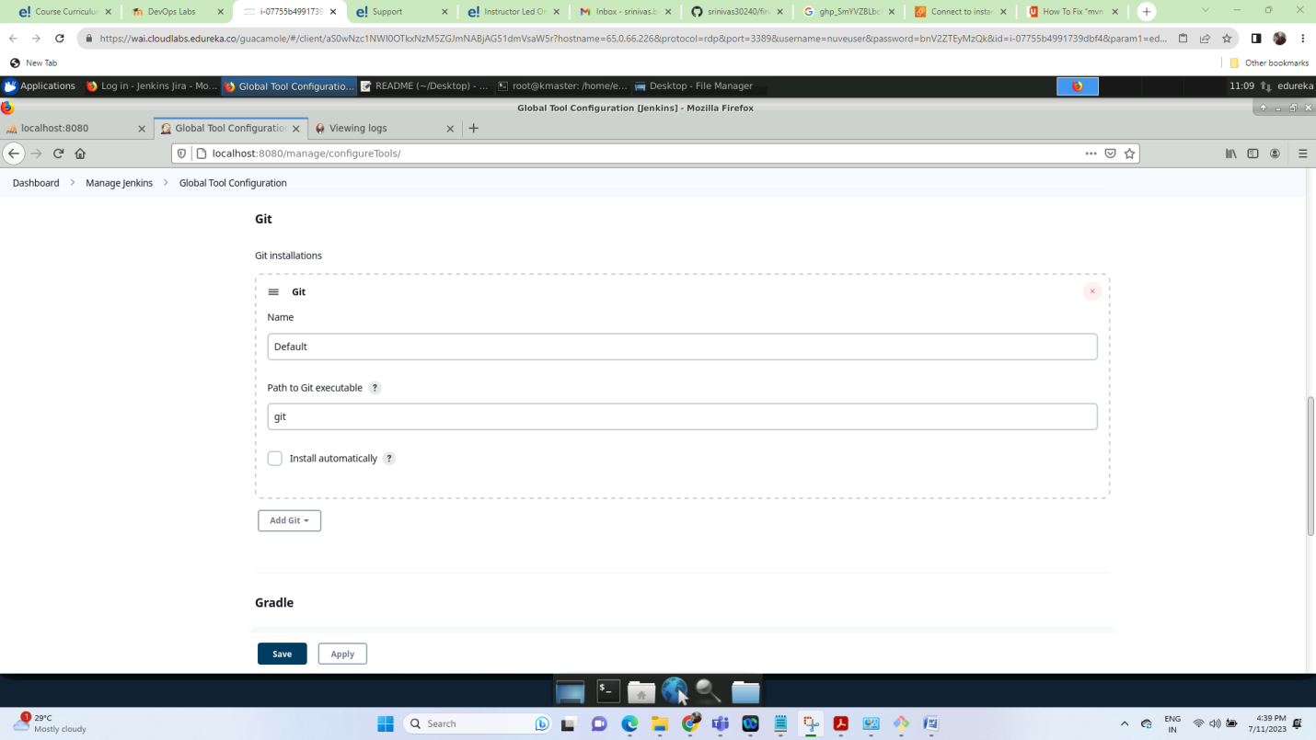

Tool configuration for maven:

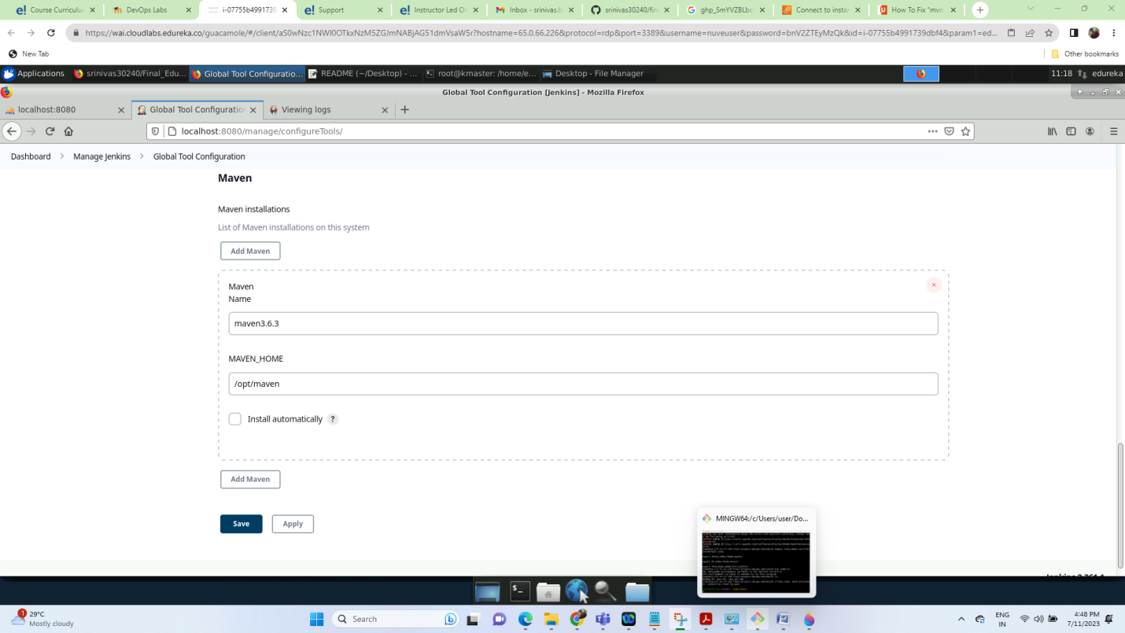

Compile job result in Jenkins:

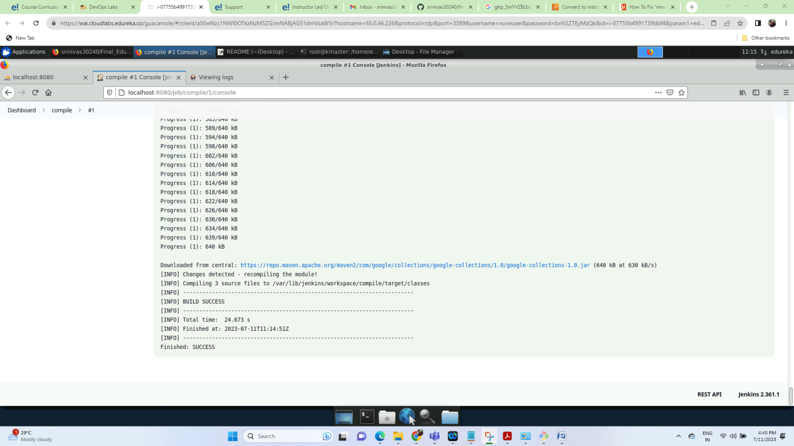

Test job results in Jenkins:

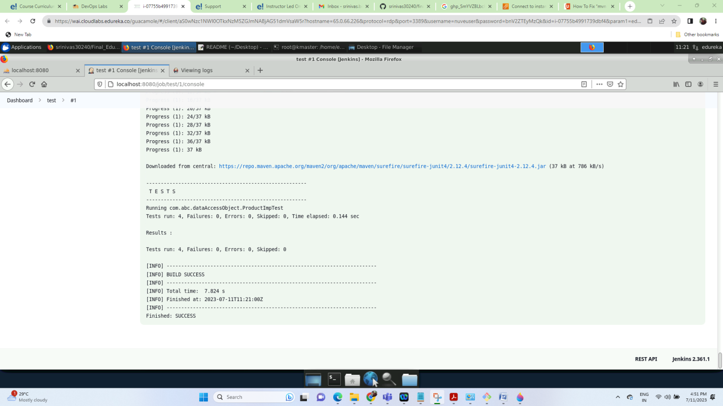

Test result for packaging:

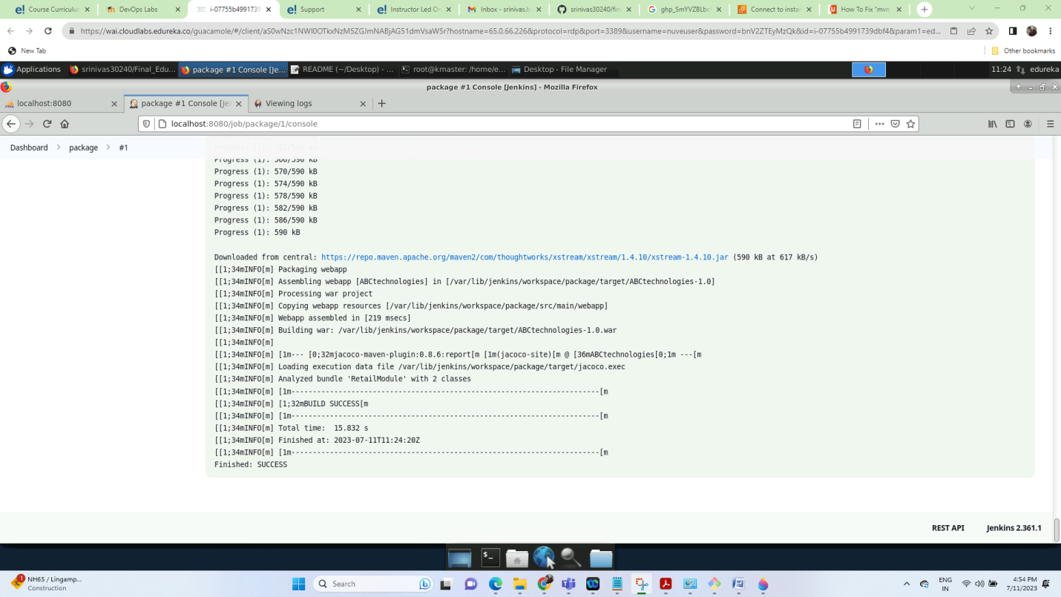

Upstream and Downstream Project:

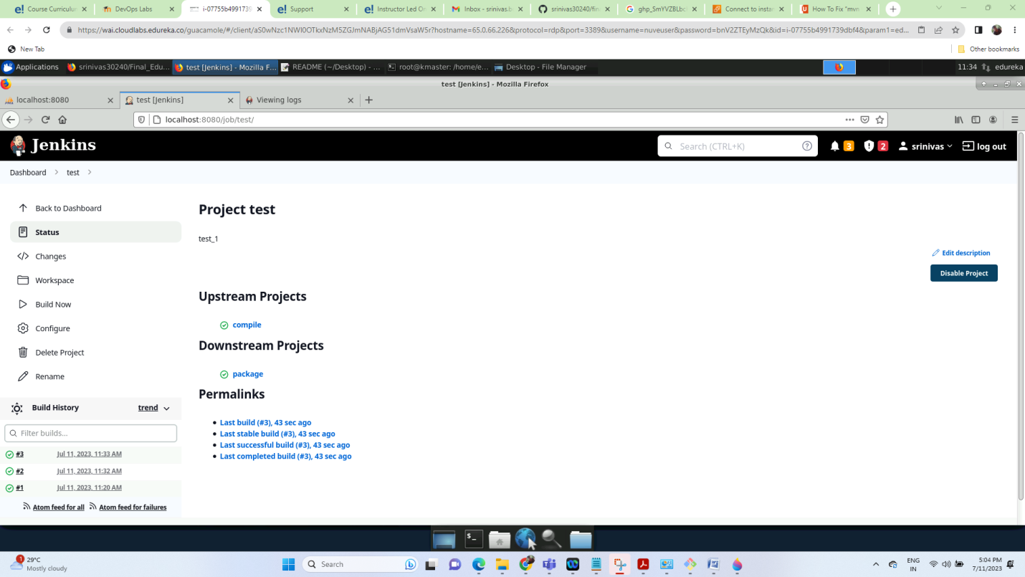

Target folder in Jenkins:

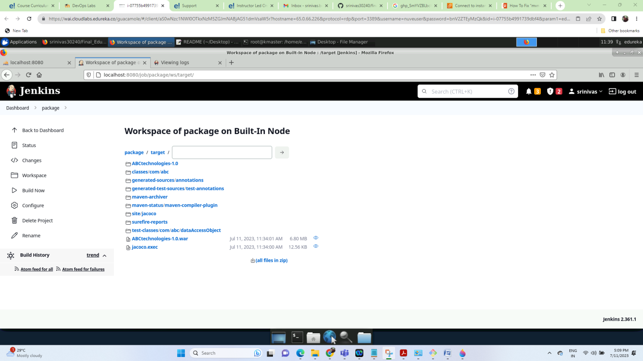

Step 2: Execute the CI/CD pipeline to execute the jobs created in step 1

CI_PIPELINE:

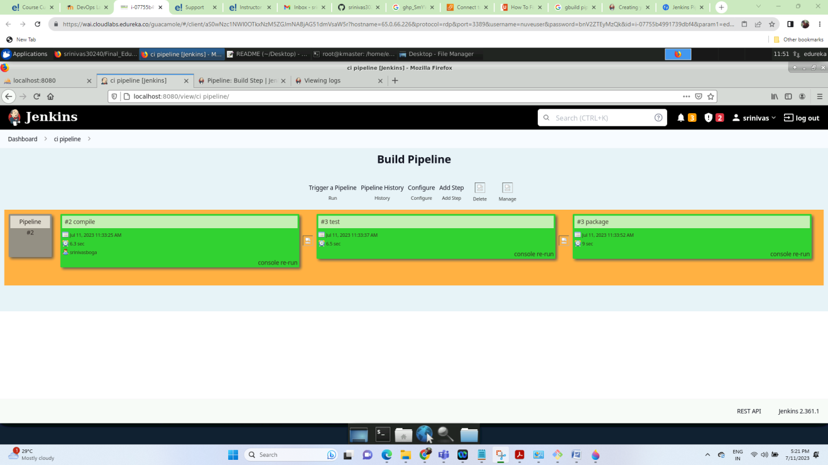

And I have configured the git polling as a cron job for a compile job that triggers for every 2 minutes for github code so that if whatever change happens then it will trigger and perform the given task.

<https://github.com/srinivas30240/Final_Edureka_project.git>

Poll SCM settings using cronjob in compile job:

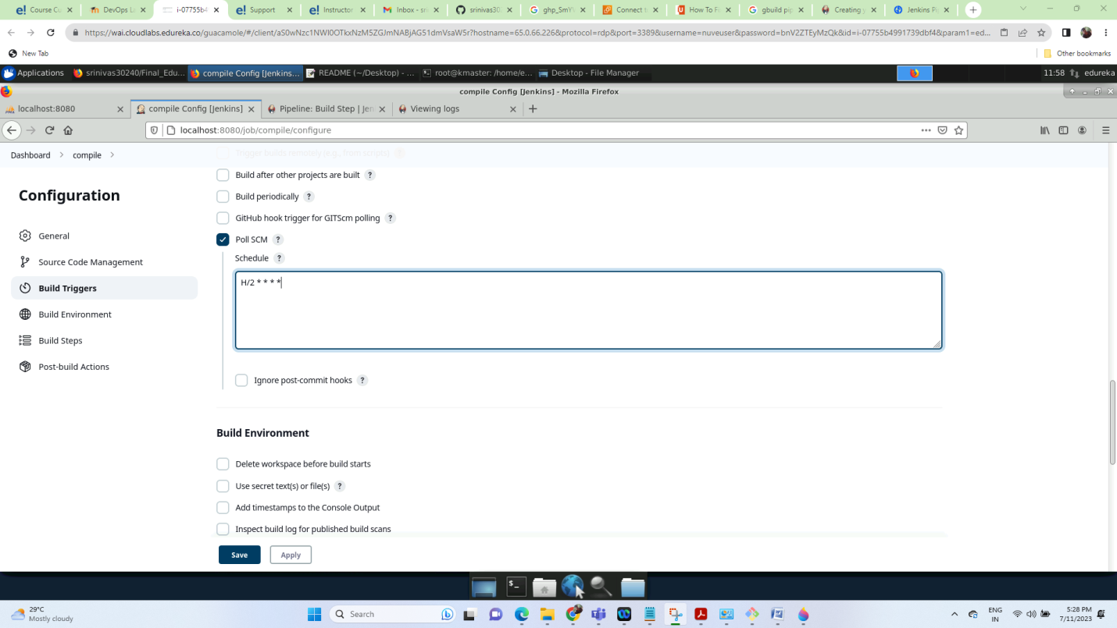

Git polling Log that it has triggered automatically after i modified the Readme file:

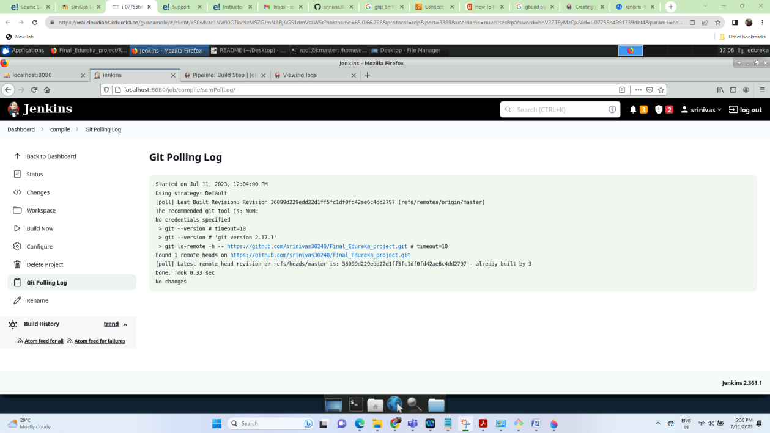

Step 3: Set up a master-slave node to distribute the tasks in the pipeline

The agent configurations:

- I have created a user Jenkins on second Linux machine so that i can run the Jenkins jobs in slave machine as well.

- When i try to configure the agent i was getting compatibility issue while running the agent

Command in agent server(slave server) and got to know that this is due to java 8

Compatibility issue beginning with Jenkins 2.357 and Jenkins 2.361.1, running the controller On Java 11 and agents on Java 8 will result in the following error:

I installed java 11 and

In cmd: update-alternatives --config java

Agent connected validation in Jenkins:

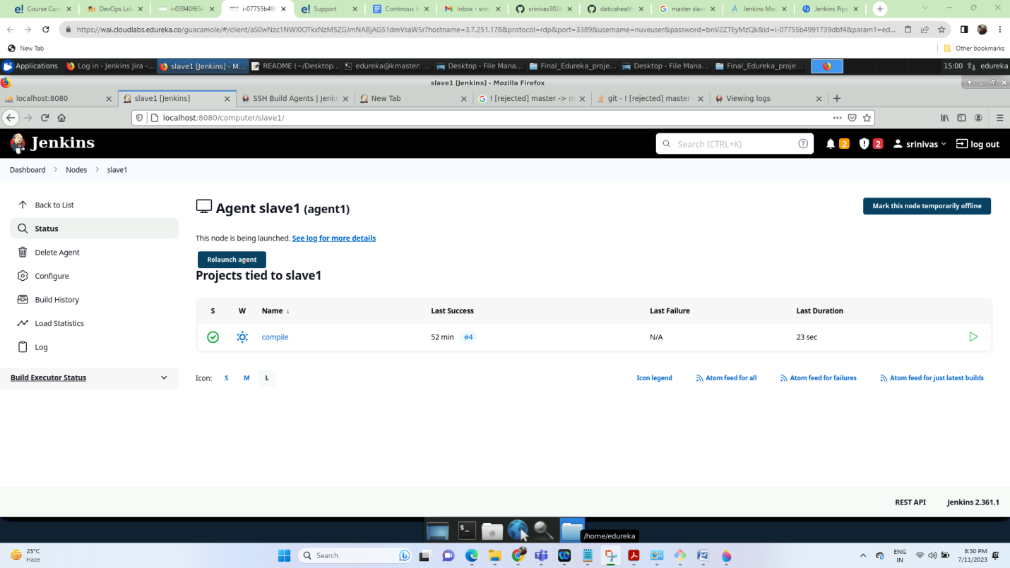

Compile job run on slave:

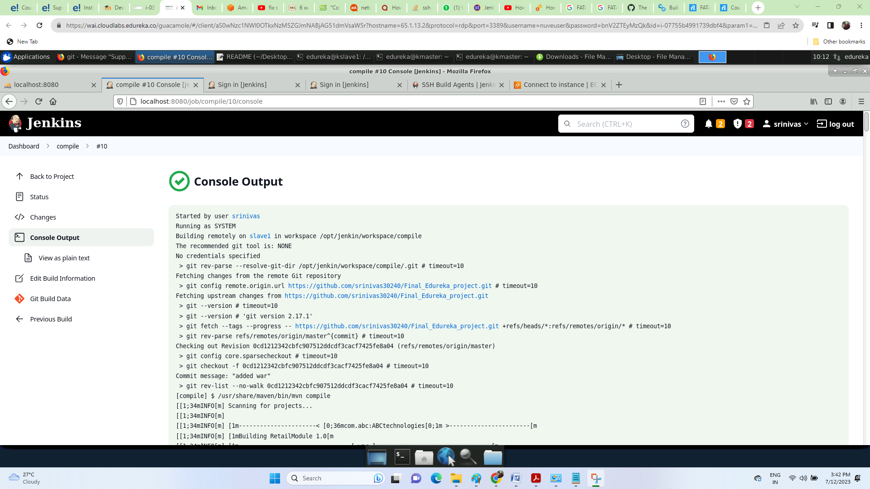

Package job run on slave1:

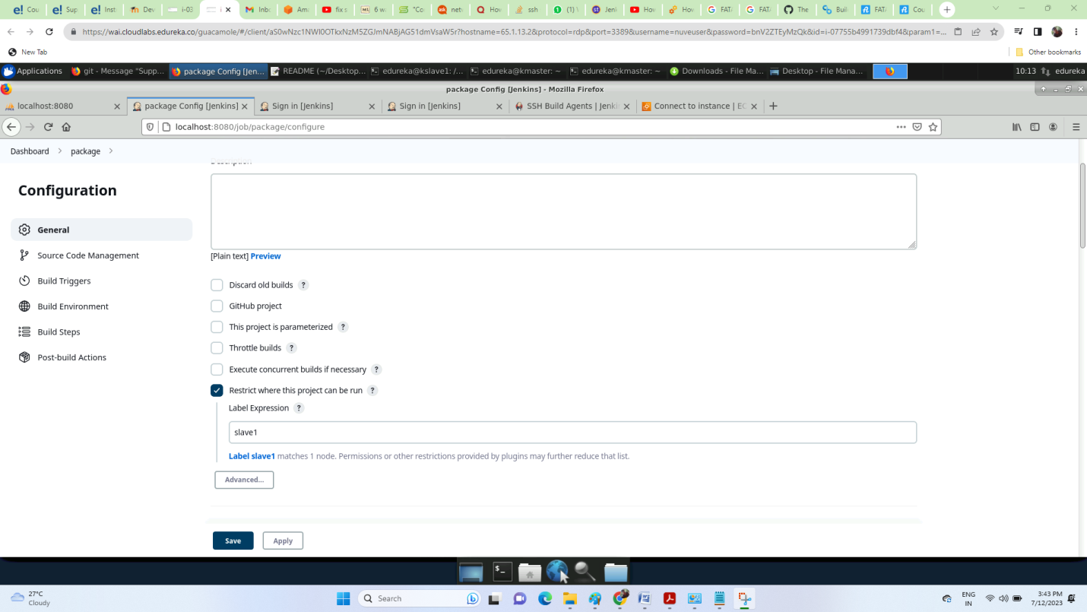

Job executing:

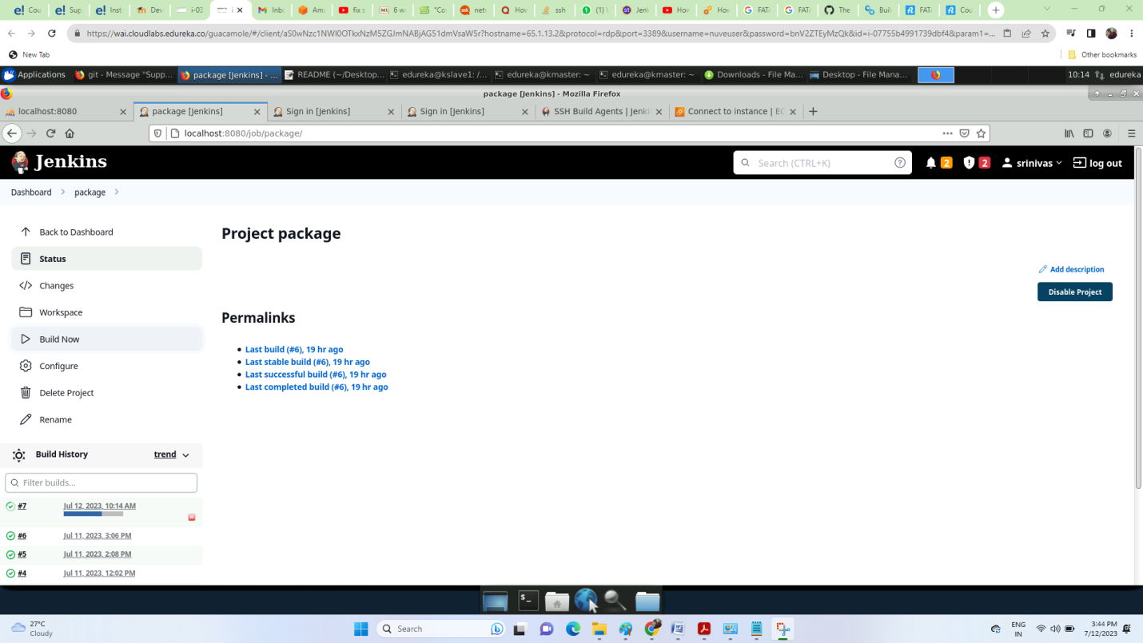

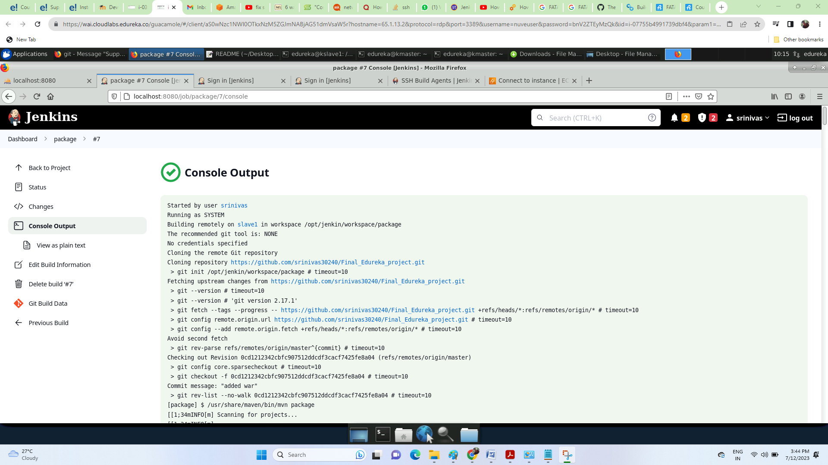

Task 3: Write a Docket file. Create an Image and container on the Docker host. Integrate docker host with Jenkins. Create CI/CD job on Jenkins to build and deploy on a container.

1. Enhance the package job created in step 1 of task 2 to create a docker image.

2. In the Docker image, add code to move the war file to the Tomcat server and build

The image

Below are the screenshots of the above 2 steps of task-3:

1. I have started Tomcat server by using commands:

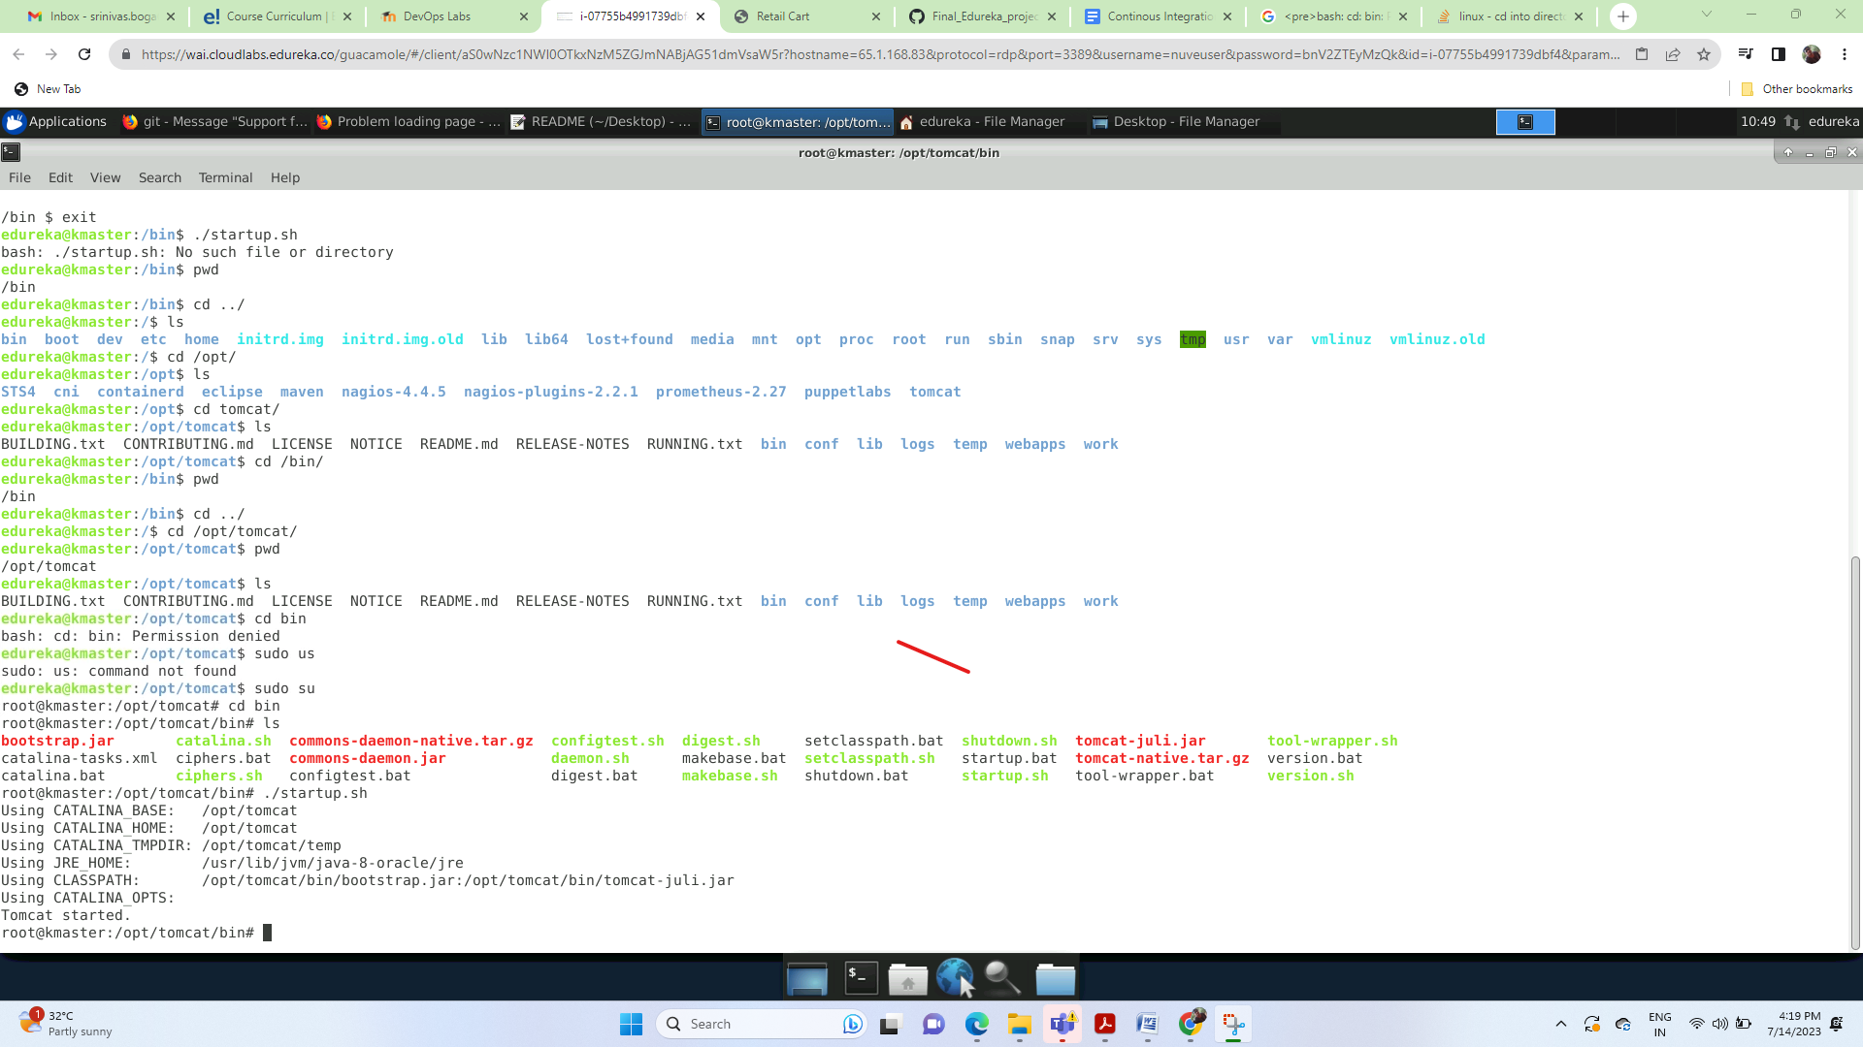

Issue: I am unable to log in tomcat sever; After running the job I got an issue and was not able to get into the tomcat so i have configured the tomcat conf/tomcat-users.xml file with the below addition to the end like I have created a user as a tomcat and password as a admin for the role of manager-gui and manager_script and later it allowed me to deployed to the tomcat successfully.

Solution:

conf/tomcat-users.xml

<role rolename="manager-gui"/>

<role rolename="manager-script"/>

<user username="tomcat" password="admin" roles="manager-gui,manager-script"/>

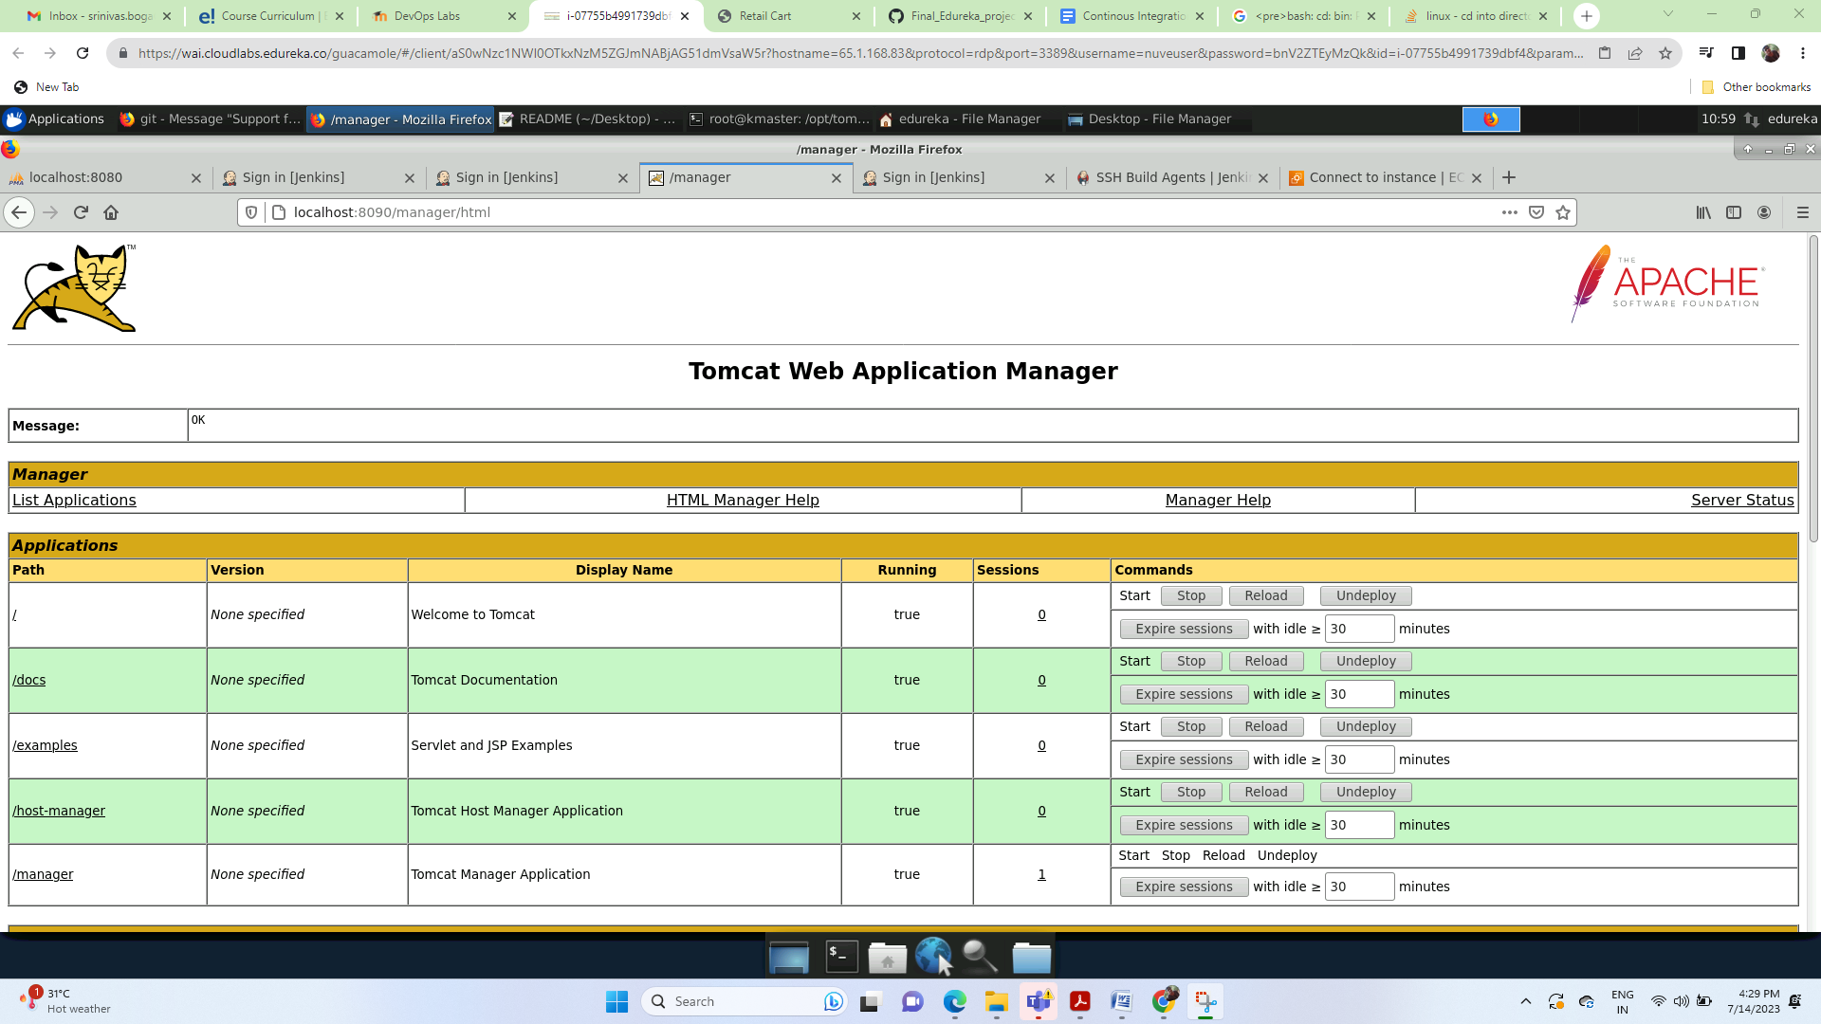

Git repo setting on Jenkins UI:

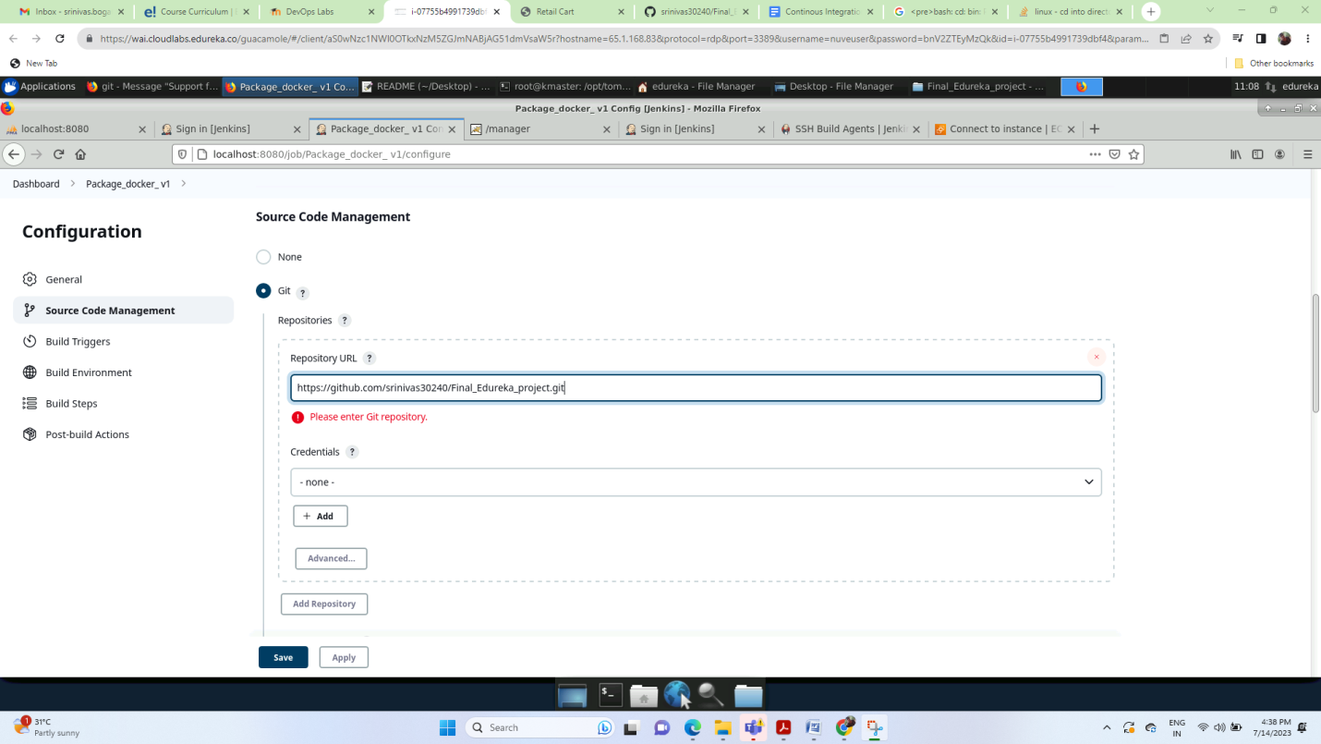

Choosing ‘Invoke top-level Maven targets’ option to add maven goal setting:

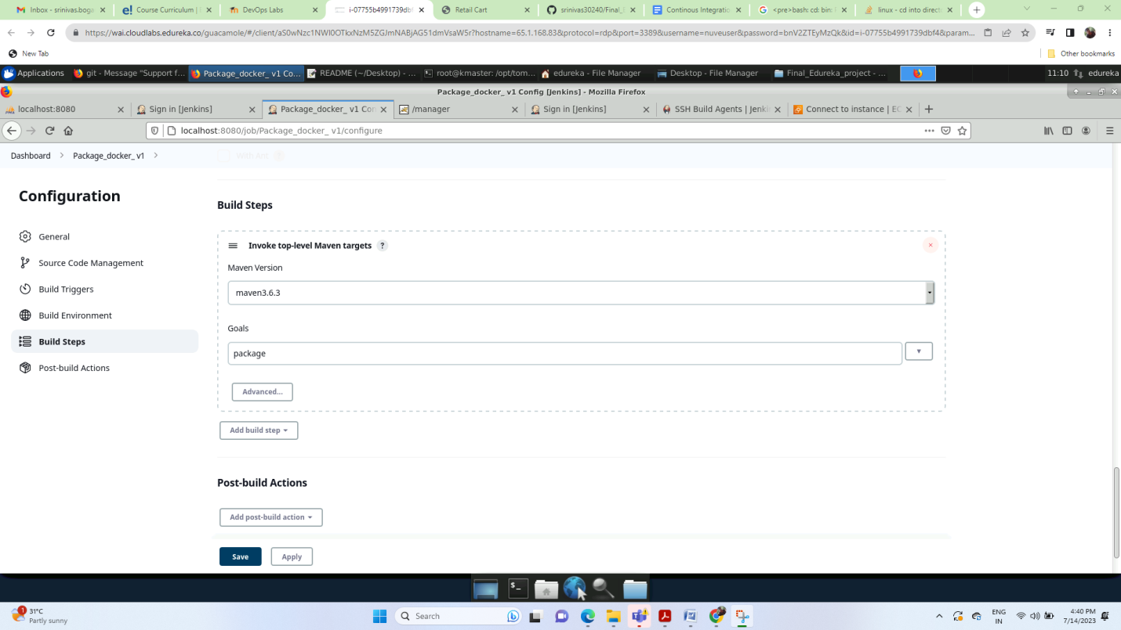

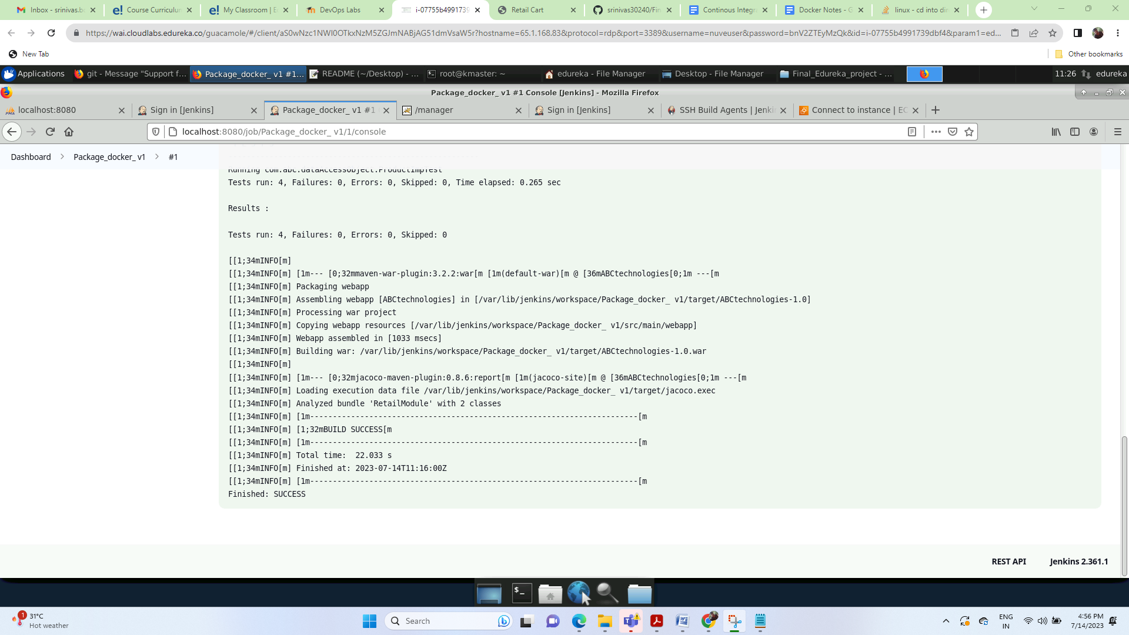

Go to console.. Scroll to bottom, you will see the path of the war file:

/var/lib/jenkins/workspace/package/ABC Technologies/target

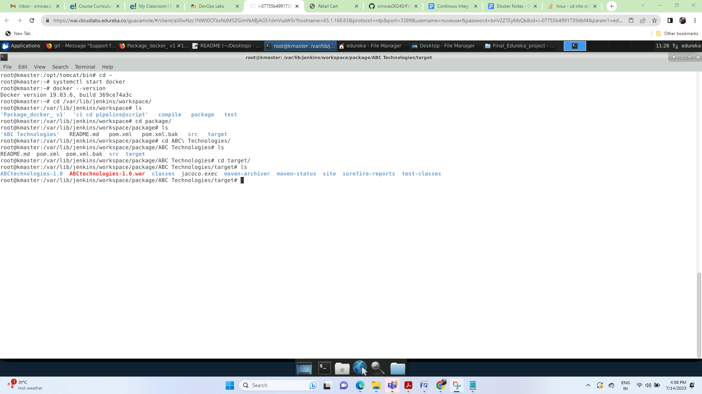

Create second job with name as ContinousDeployment on tomcat on my machine:

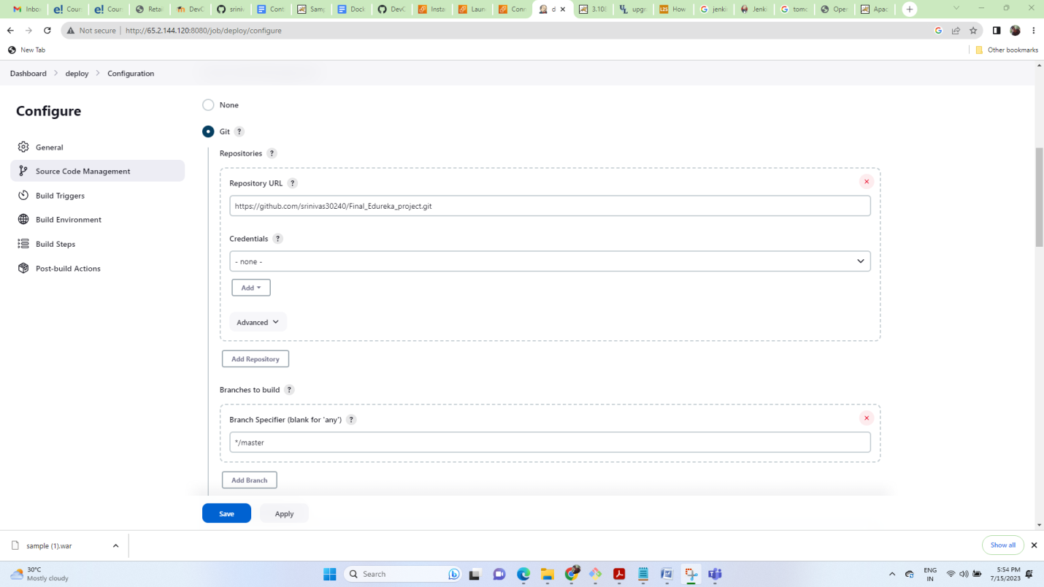

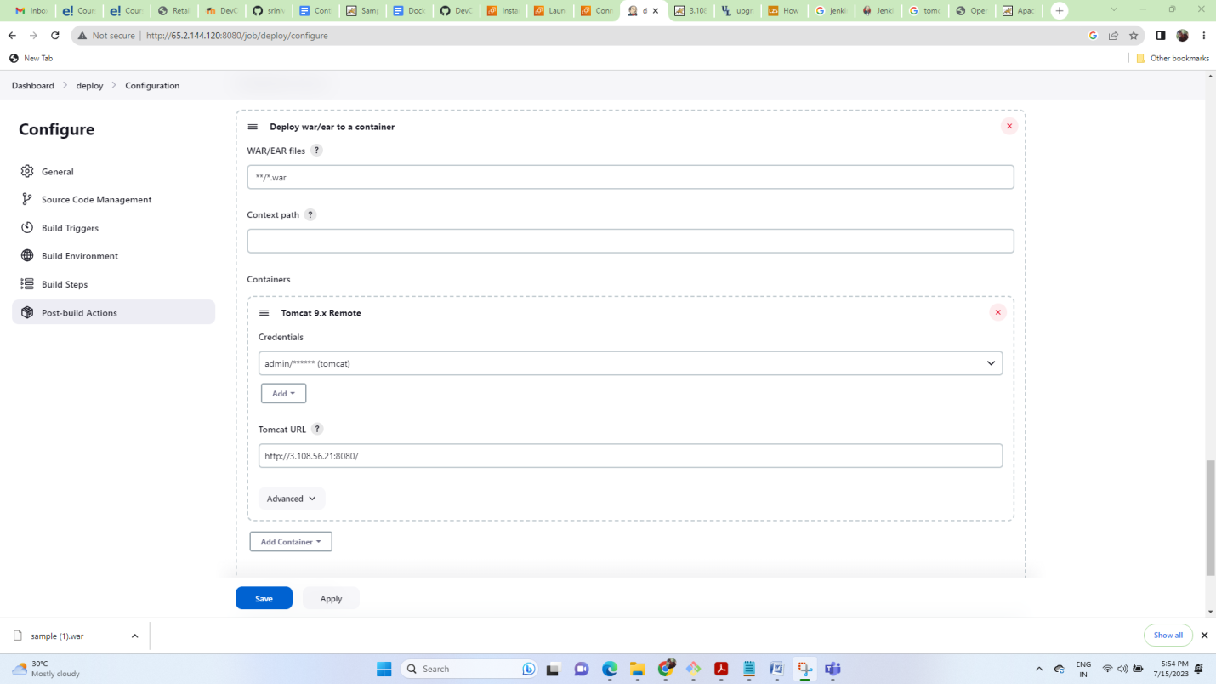

Excute the job on Jenkins on we can access from http://3.108.56.21:8080/ABCtechnologies-1.0/

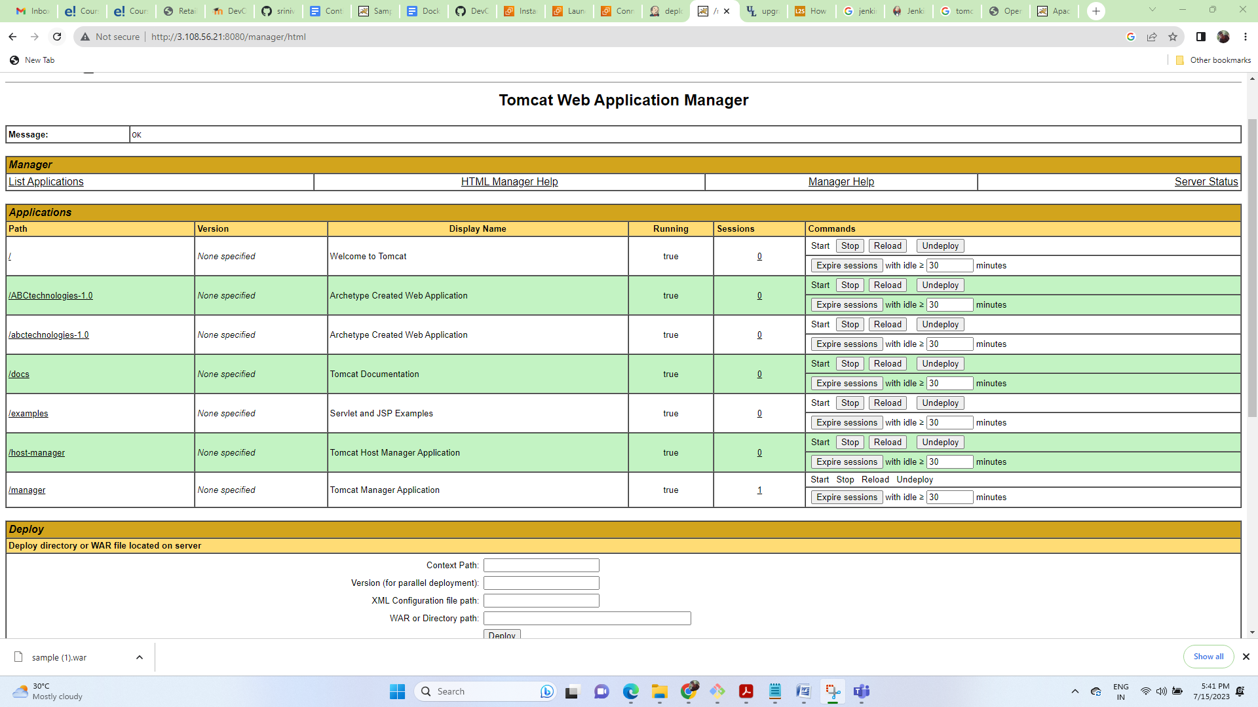

# Docker and Jenkins Integration:

Package_docker_V1_ job settings:

systemctl start Jenkins

systemctl start docker

Create a job with name as ContinousIntegration

Add the repo in SCM as <https://github.com/srinivas30240/Final_Edureka_project.git>

Add the build steps as maven targets

Select maven version as maven3.6.3

Select the goal as clean install package

Save the job and build it.

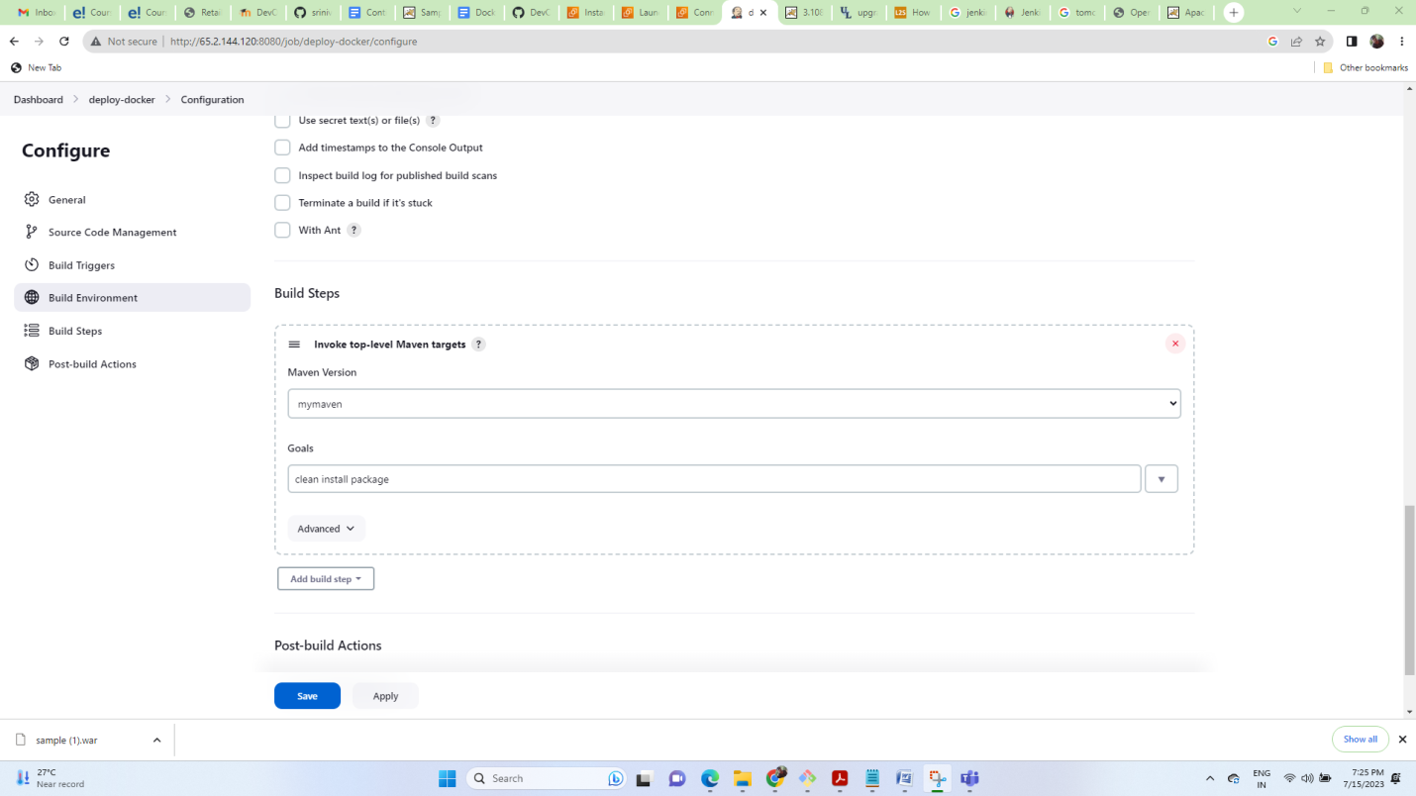

rm -rf mydockerfile

# Create a new directory will have the new .war file and dockerfile

mkdir mydockerfile

# go inside the directory

cd mydockerfile

# copy the addressbook.war file from the previous job

cp /var/lib/jenkins/workspace/deploy-docker/target/abctechnologies-1.0.war .

# create a dockerfile

touch dockerfile

cat <<EOT>> dockerfile

FROM tomcat:9

ADD abctechnologies-1.0.war /usr/local/tomcat/webapps

EXPOSE 8080

CMD ["catalina.sh", "run"]

EOT

sudo docker build -t abctechnologies-1.0:$BUILD_NUMBER .

sudo docker run -d –P abctechnologies-1.0:$BUILD_NUMBER

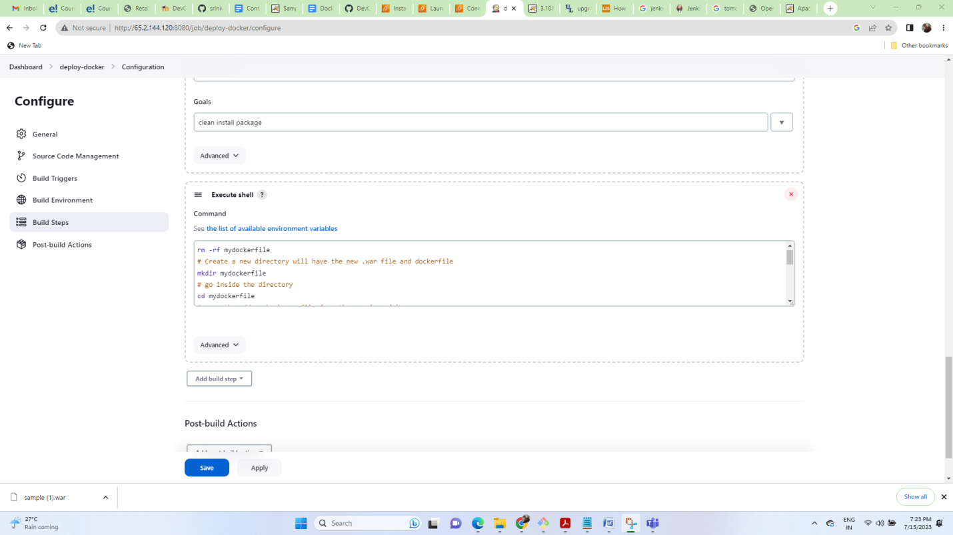

After execute: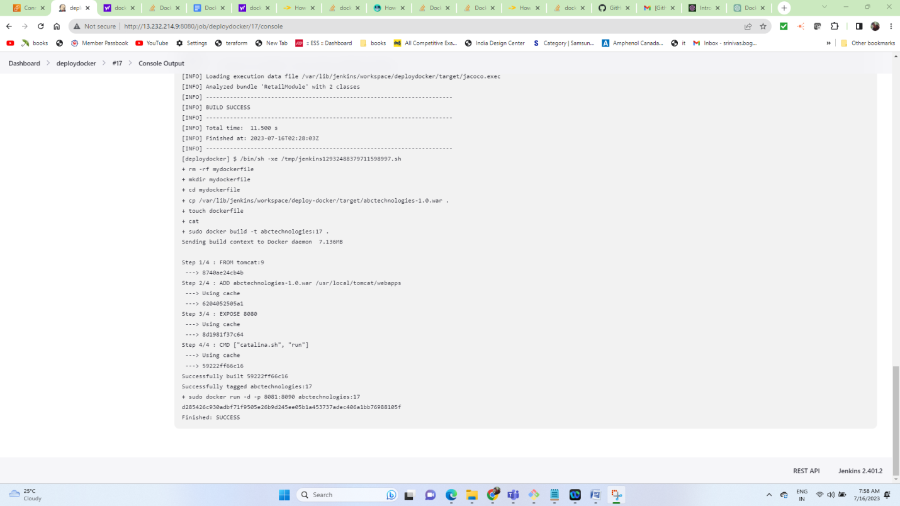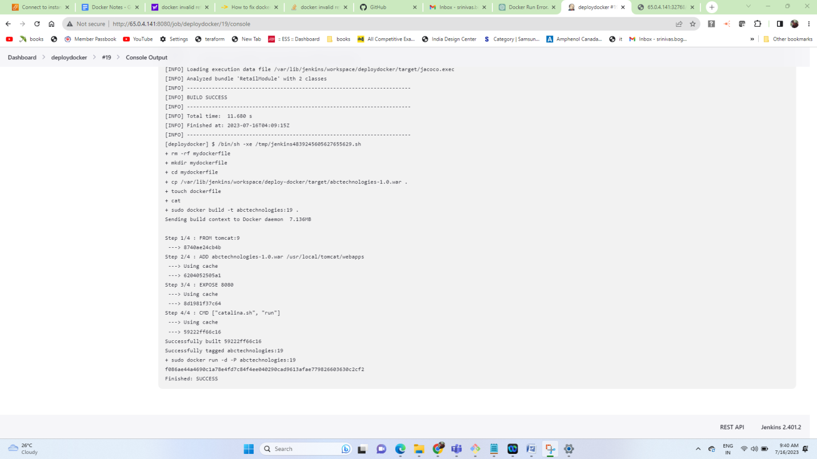

From CMD:

Docker image and container validation in browser

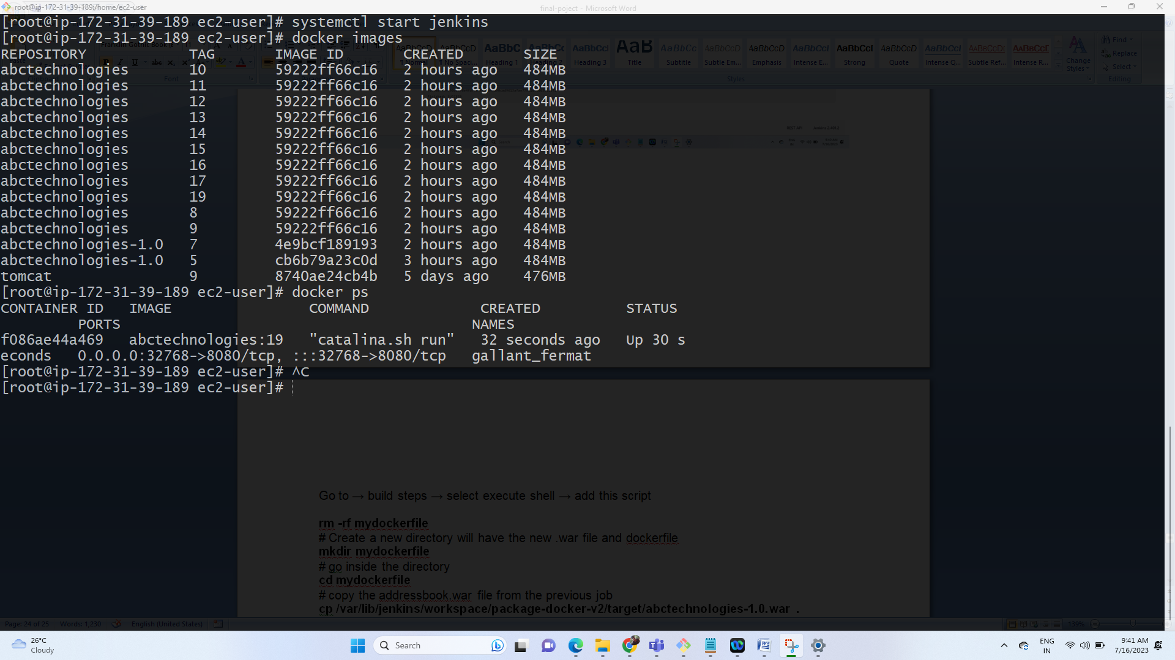

Tomcat browser validation

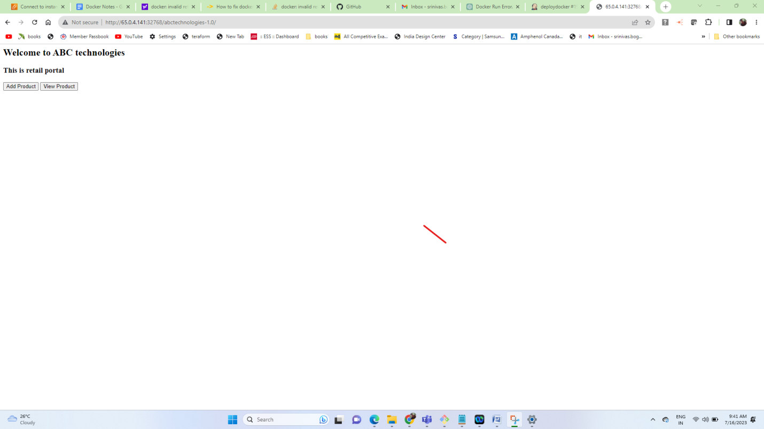

Push image to docker hub:

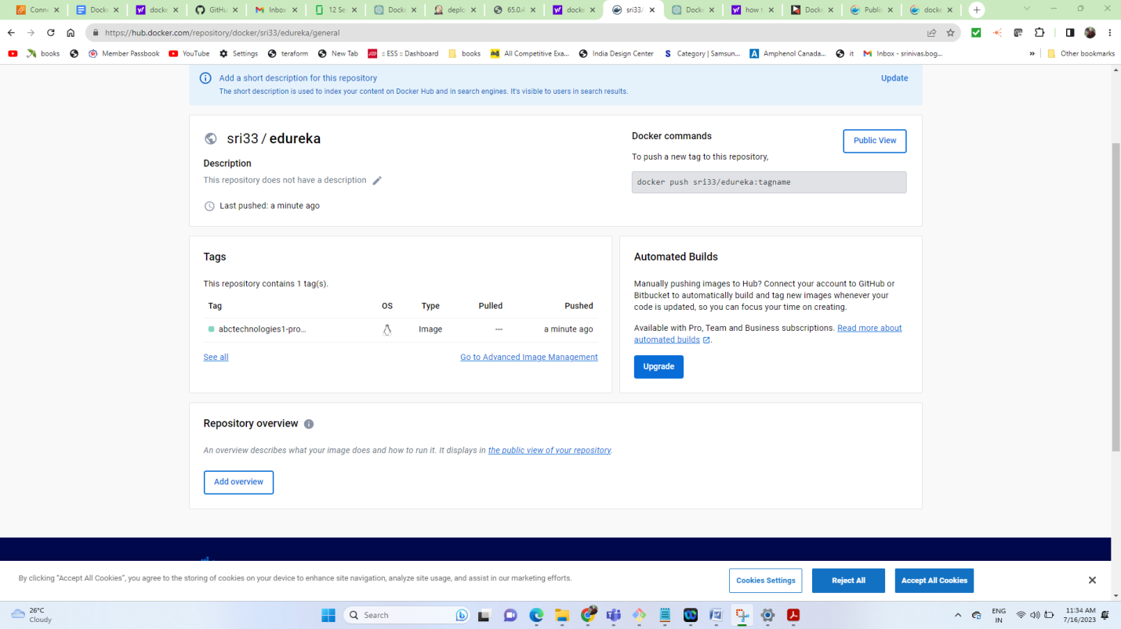

Task 4: Integrate the Docker host with Ansible. Write an Ansible playbook to create an image and create a continuer. Integrate Ansible with Jenkins. Deploy Ansible-playbook.

CI/CD job to build code on ansible and deploy it on docker container.

1. Deploy Artifacts on Kubernetes

2. Write pod, service, and deployment manifest file

3. Integrate Kubernetes with Ansible

4. Ansible playbook to create deployment and service

I used my own laptop and installed ansible and Jenkins and docker on ubuntu image.

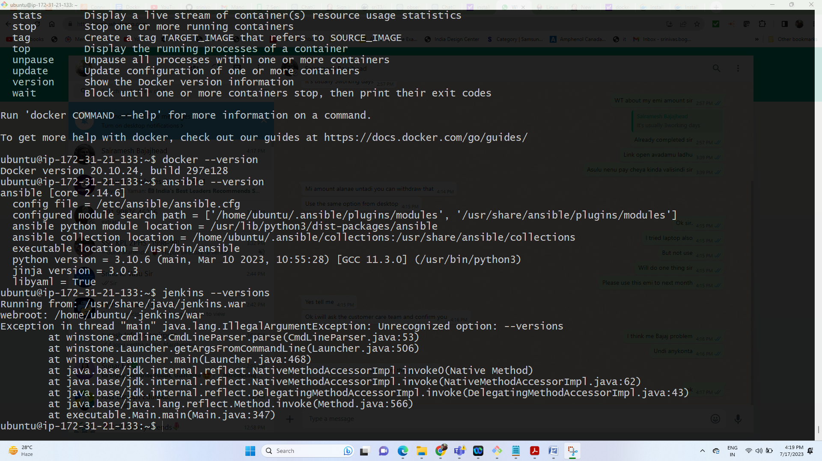

The github repo with Inventory file, code file and playbooks:

https://github.com/srinivas30240/Final_Edureka_project.git

Step 2:

On the ACM install Jenkins

Once Jenkins setup is complete

Install Ansible plug-in on Jenkins,

 Also configure Ansible tool under global tool configuration

Name: myansible

The path of ansible : /usr/bin

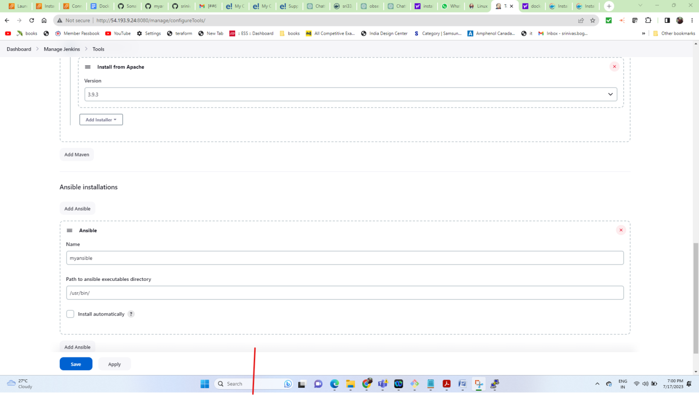

Next PIPELINE : we used already buileded war file from git repo and wrote the pipeline script

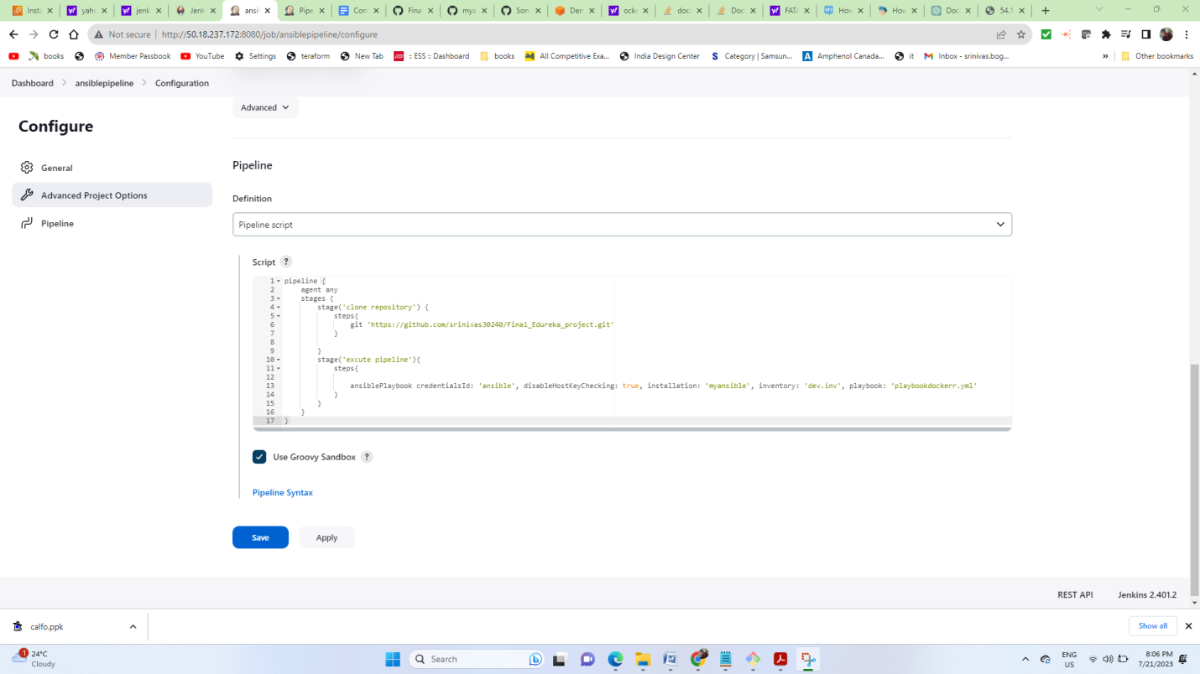

Next executed script from ACM to host from play book.yml

<https://github.com/srinivas30240/Final_Edureka_project.git>

play book and docker file is available in git repository

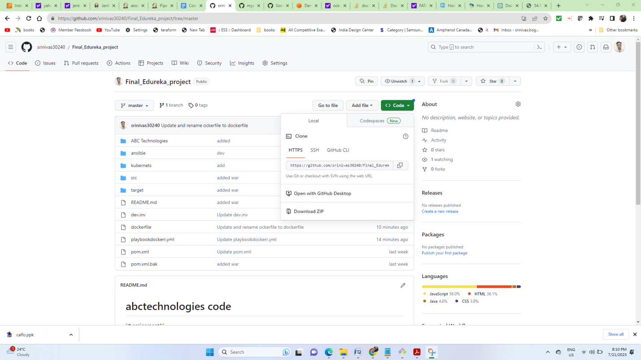

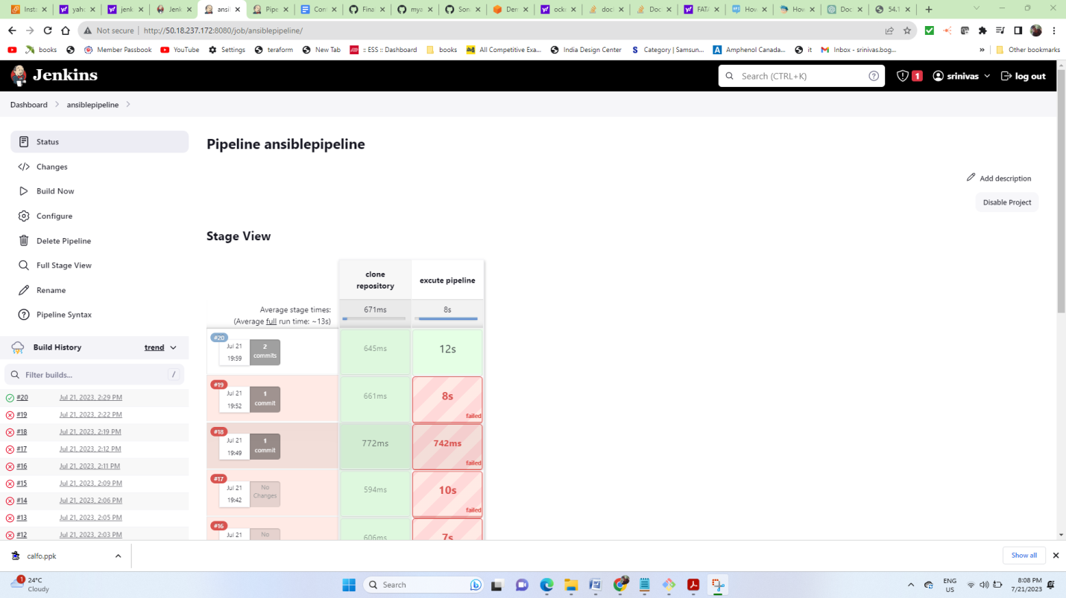

Cloning repo on host :

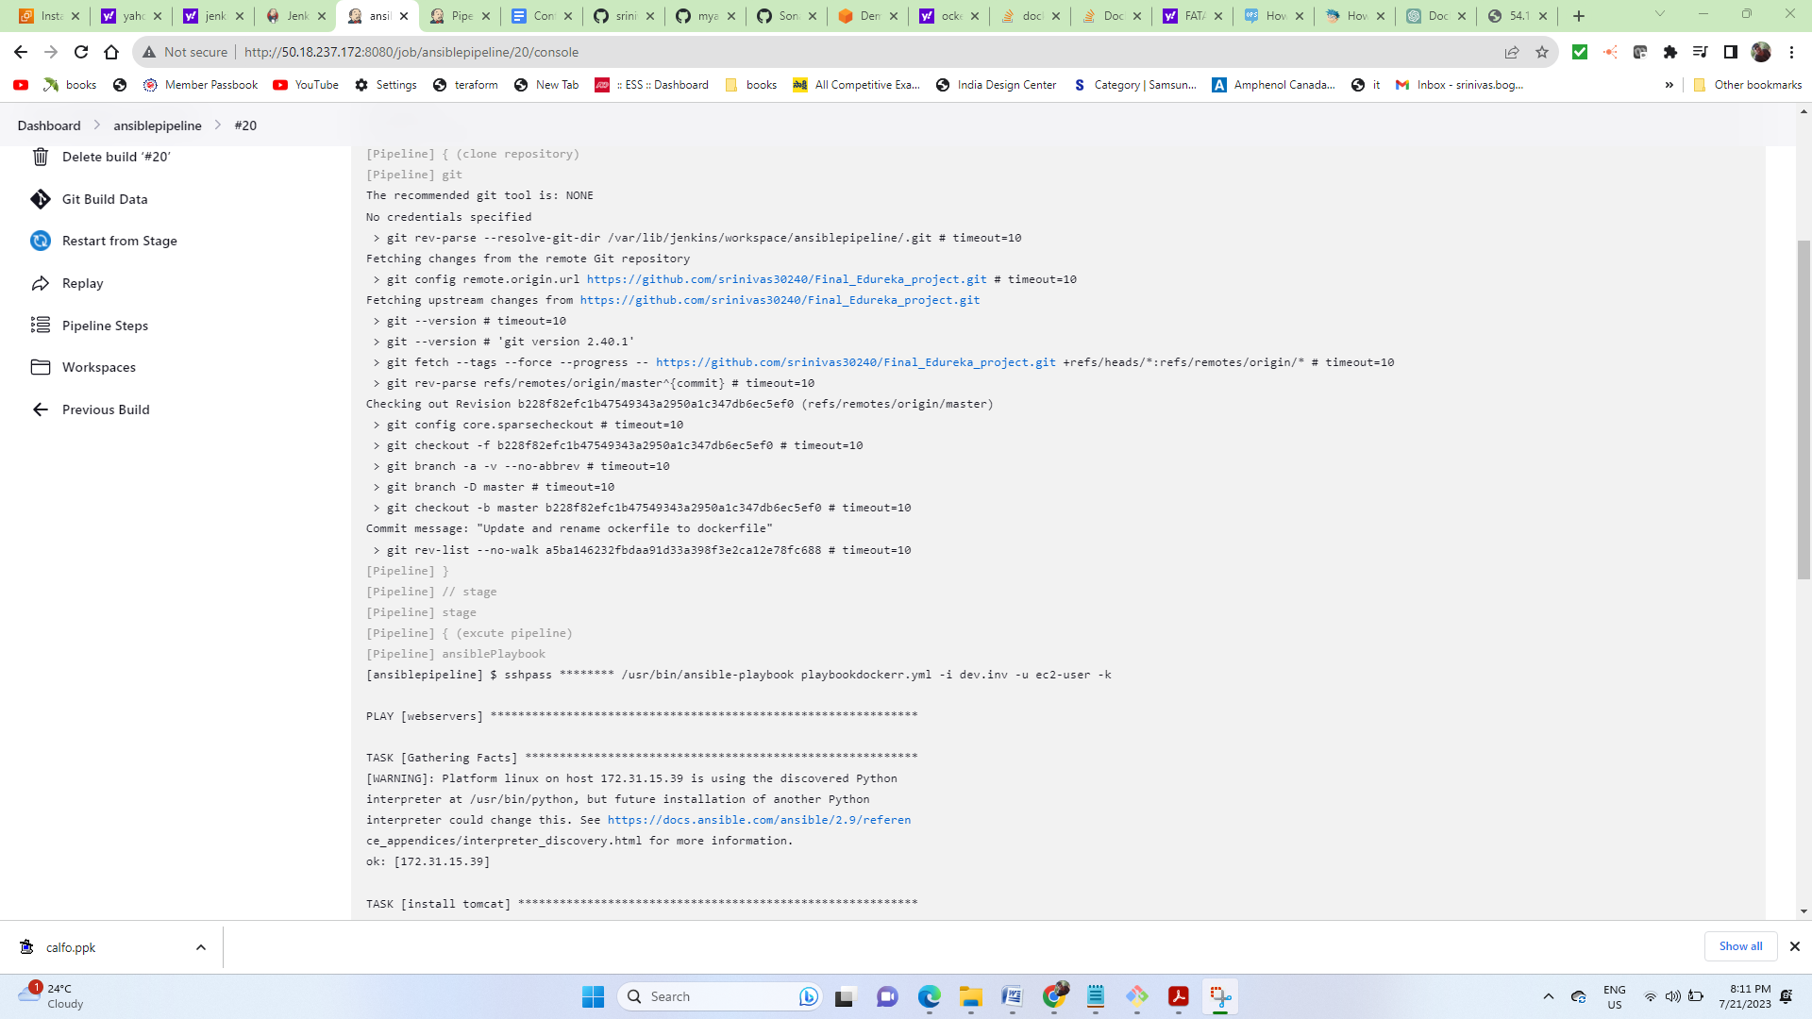

Installing tomcat, git, docker on host

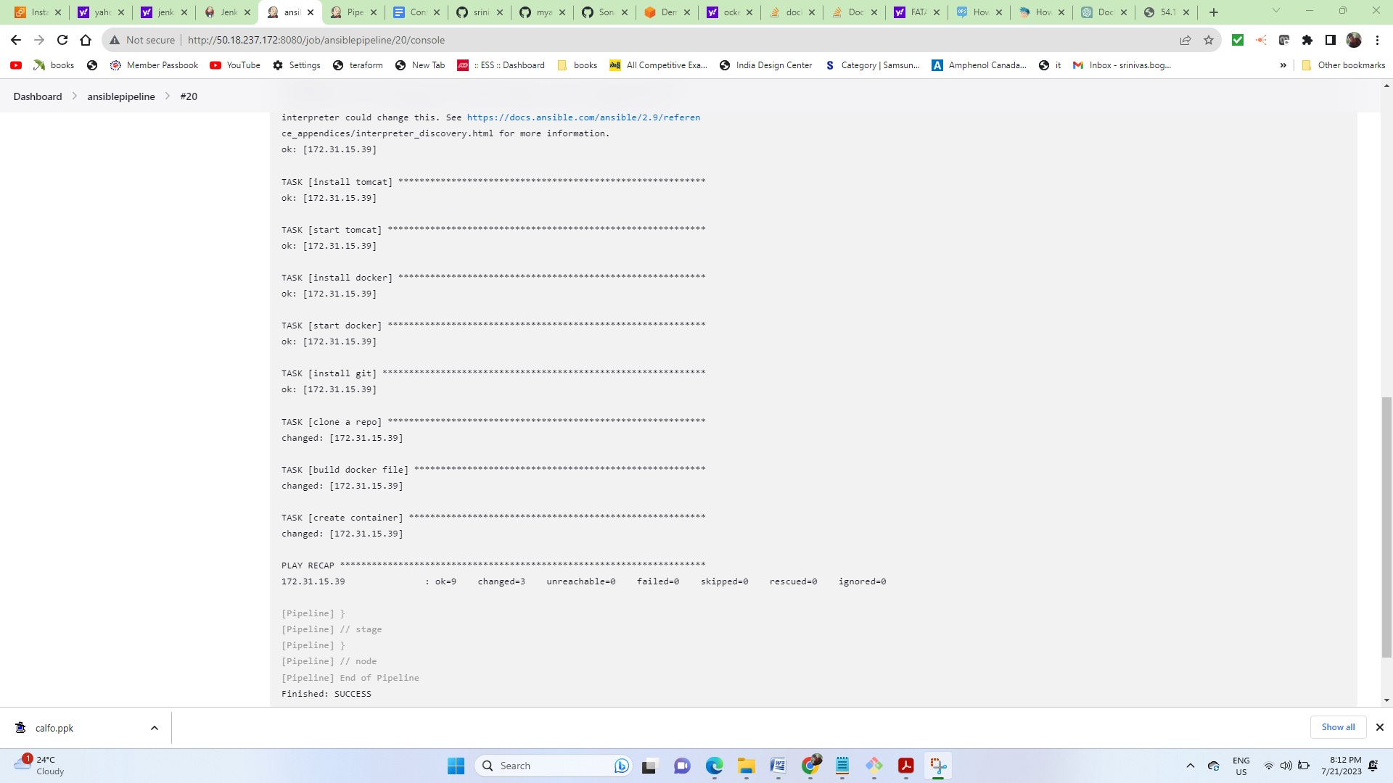

Docker container validation

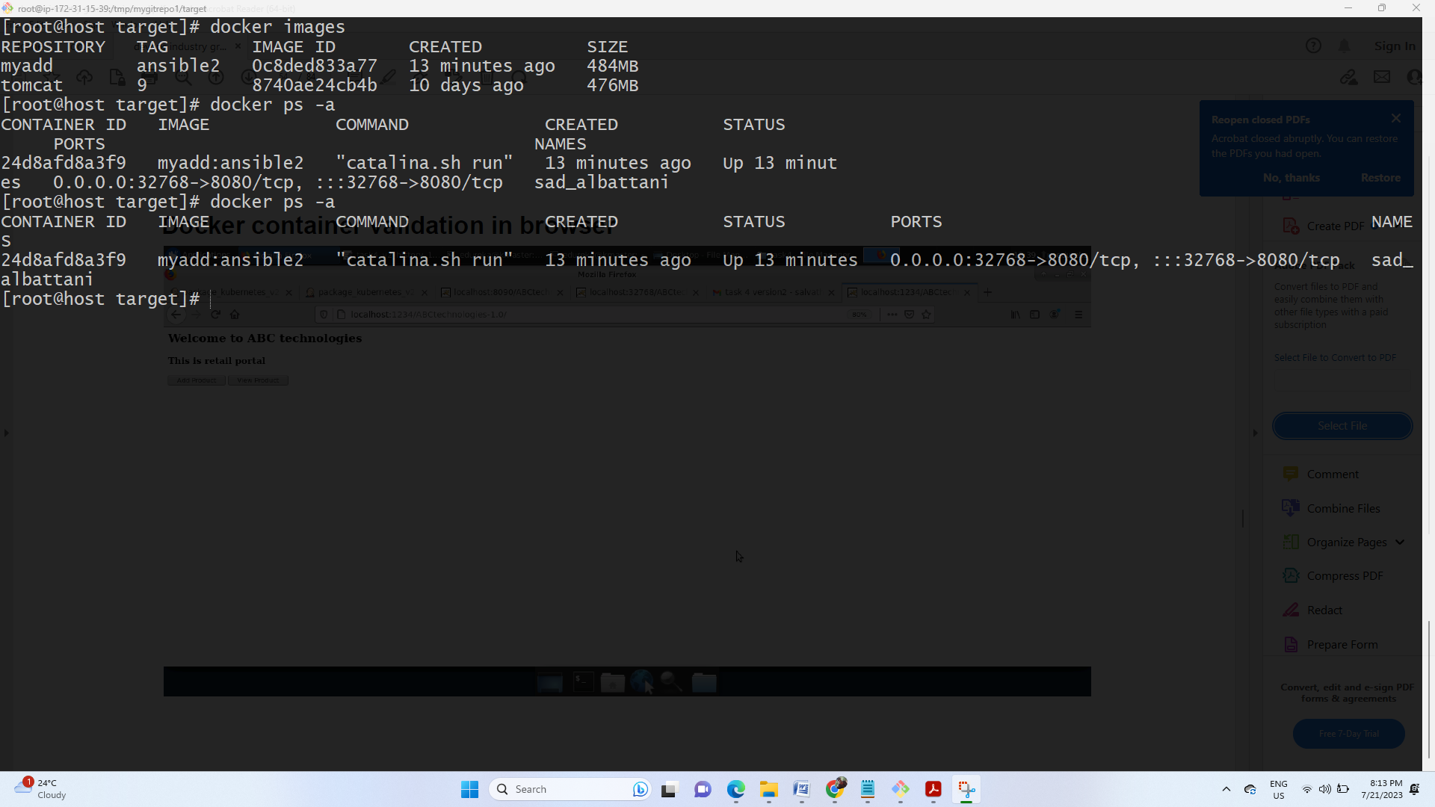

Docker container validation in browser

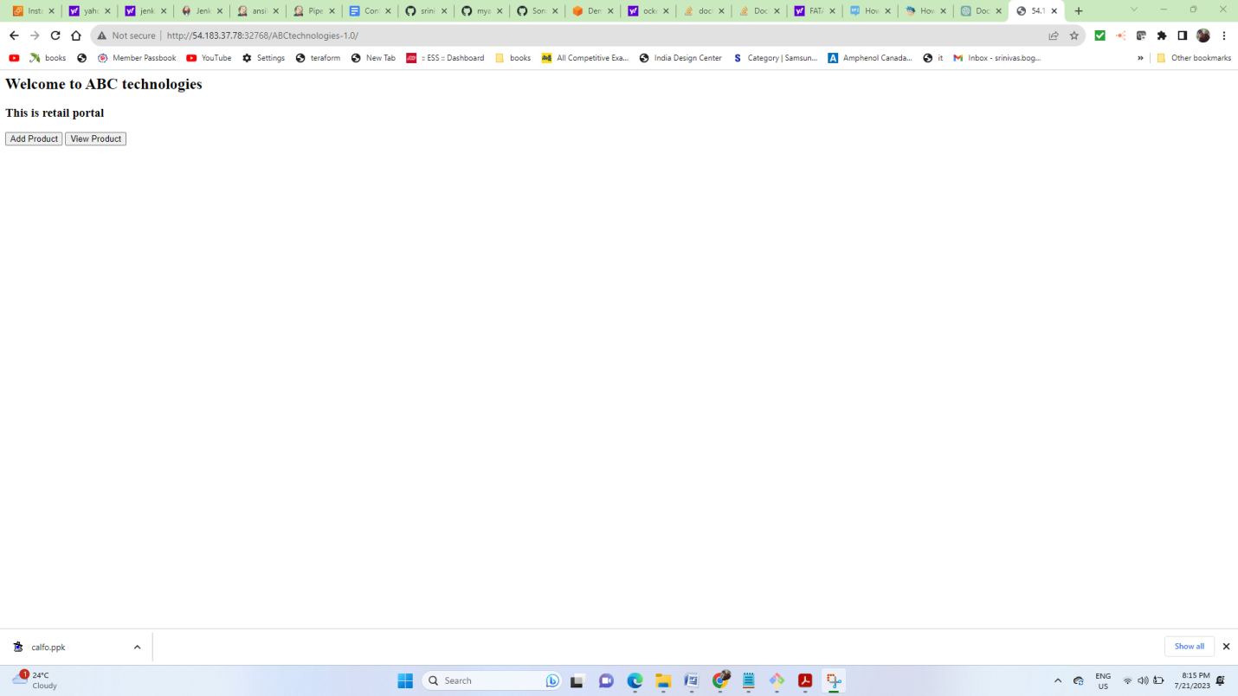

I am integrating kubernets in Jenkins and using EDUREKA LAB

HERE I am done whole CI & CD process by using pipeline script

First step: I added Git repo and packaged war file

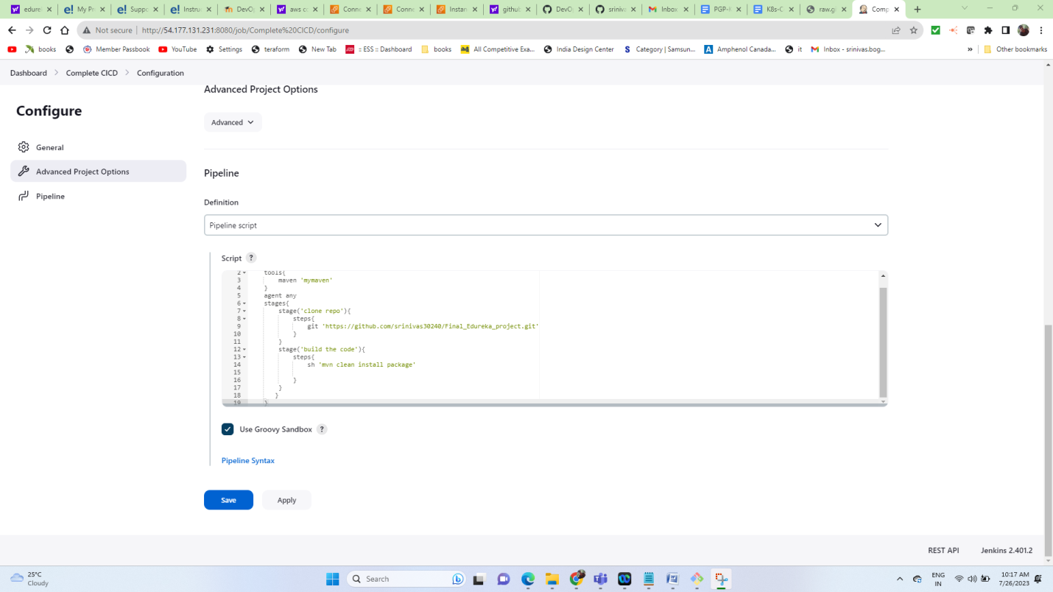

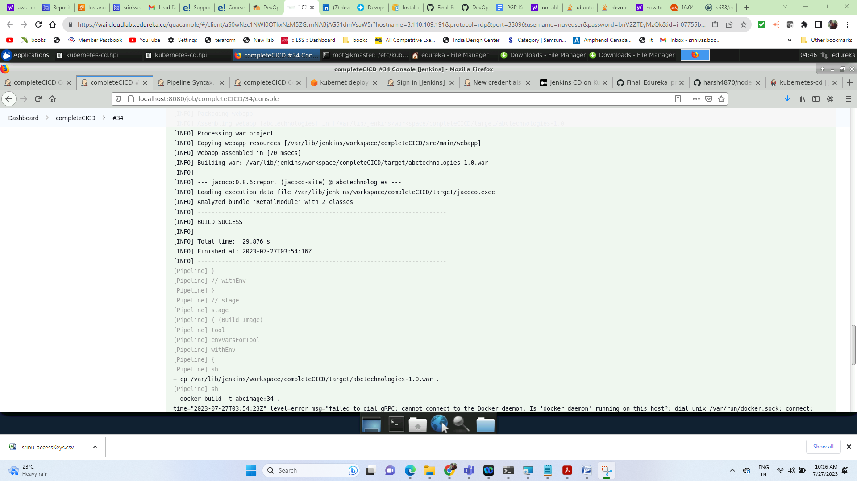

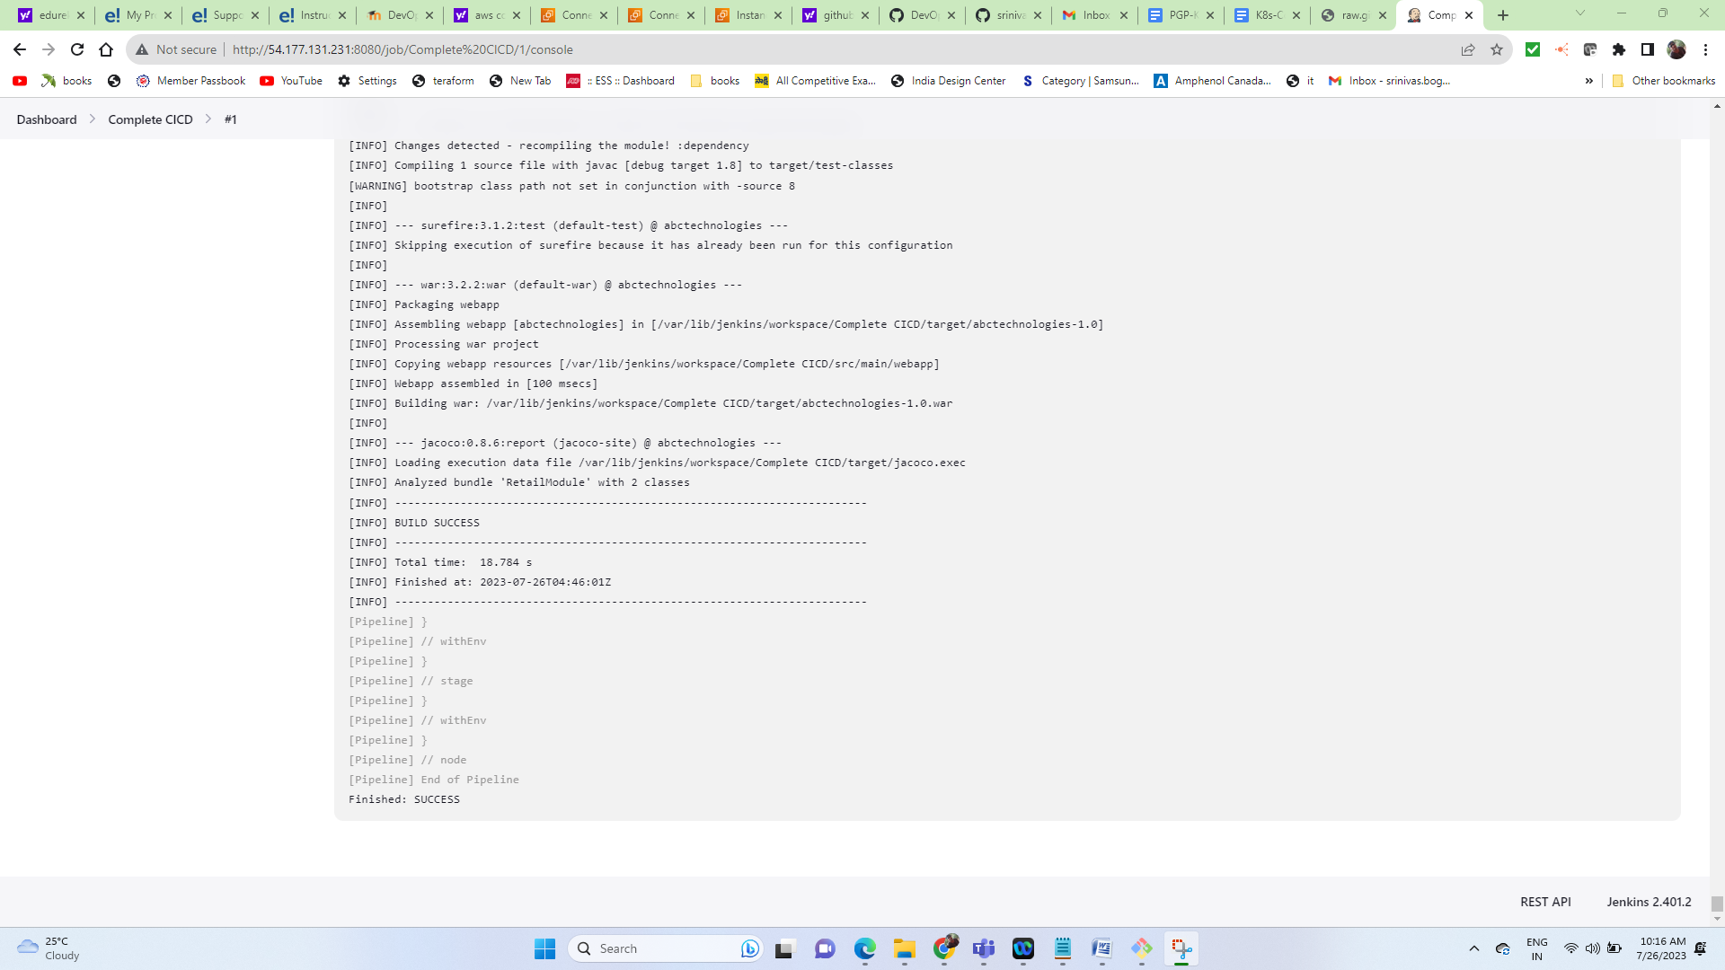

/var/lib/jenkins/workspace/Complete CICD/target/abctechnologies-1.0.war

While doing this task i have encounter some issues as below

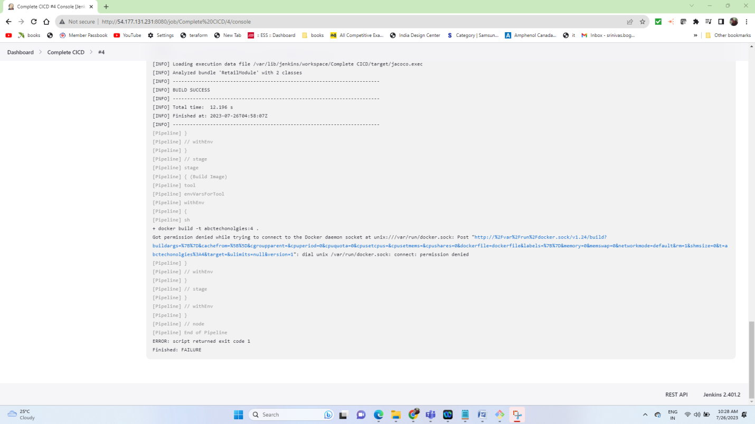

Issue1:

Permission error

Solution:

And add this permission for jenkins user in /etc/sudoers file,:: jenkins ALL=(ALL) NOPASSWD: ALL

Change permissions for jenkins to run docker commands:: chmod 777 /var/run/docker.sock

Pushing image to docker Hub:

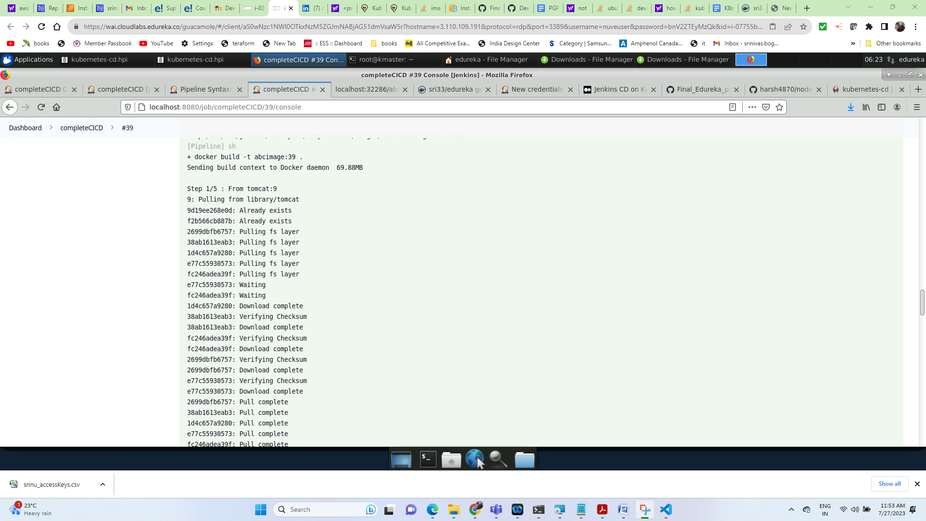

Deploying to kubernetes has been started

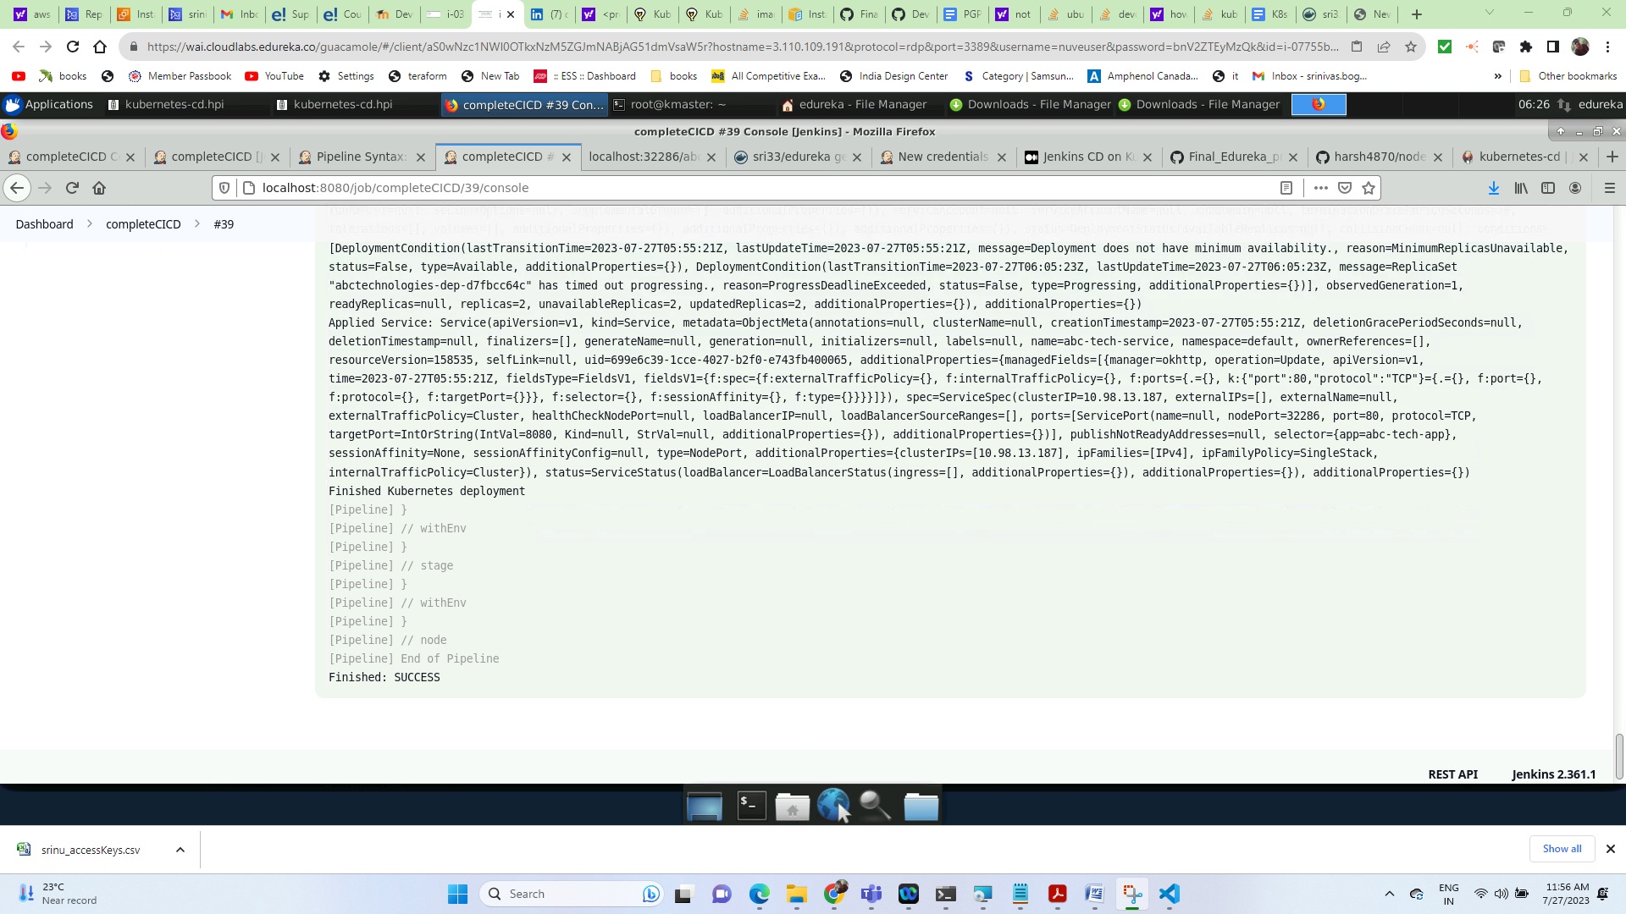

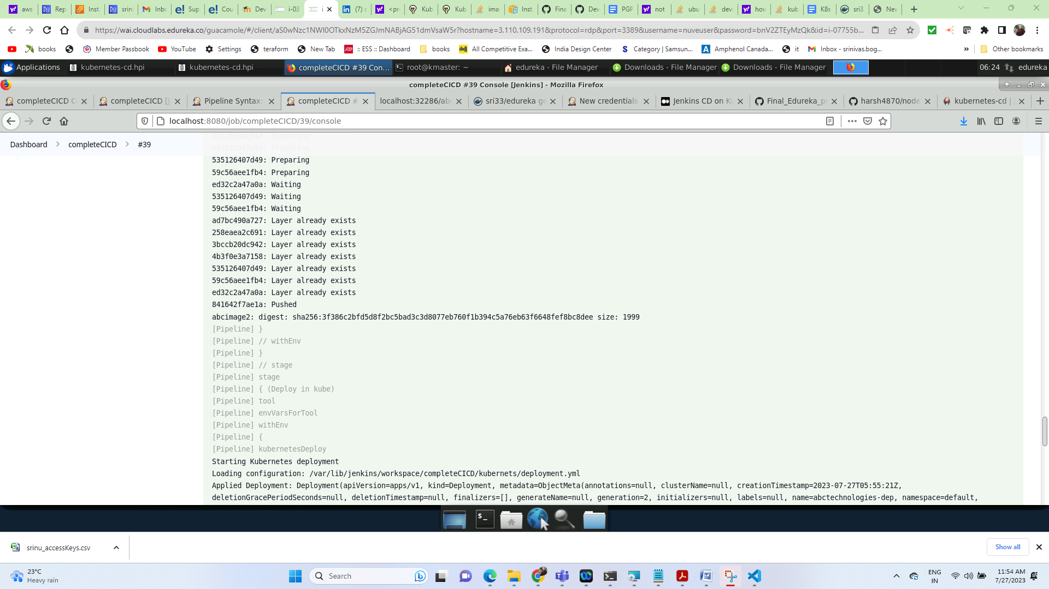

Dockerhub image in dockehub

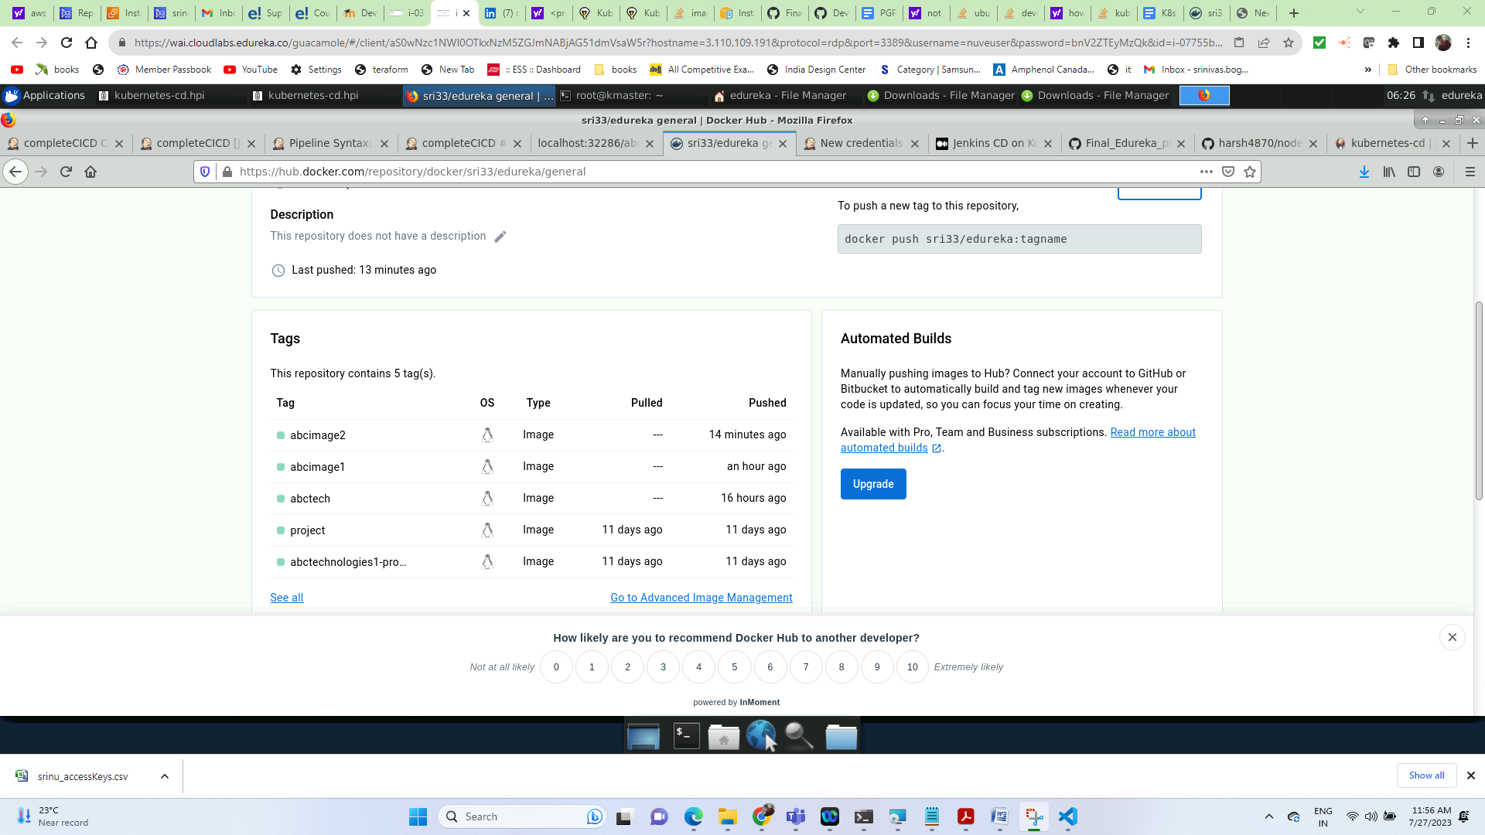

Validating kubernetes validation resources (deployment, pods, service)

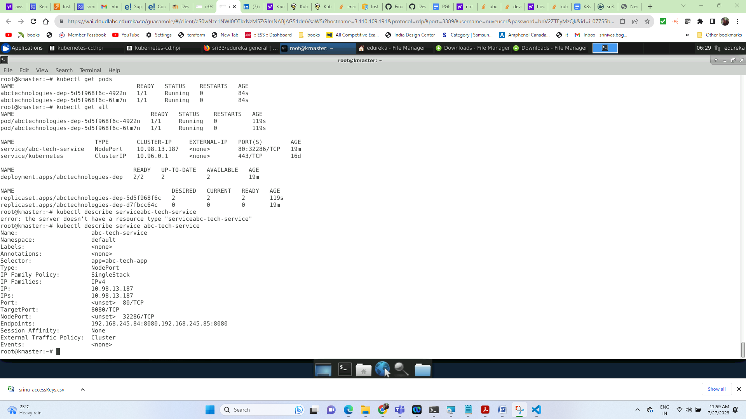

PIPELINE:

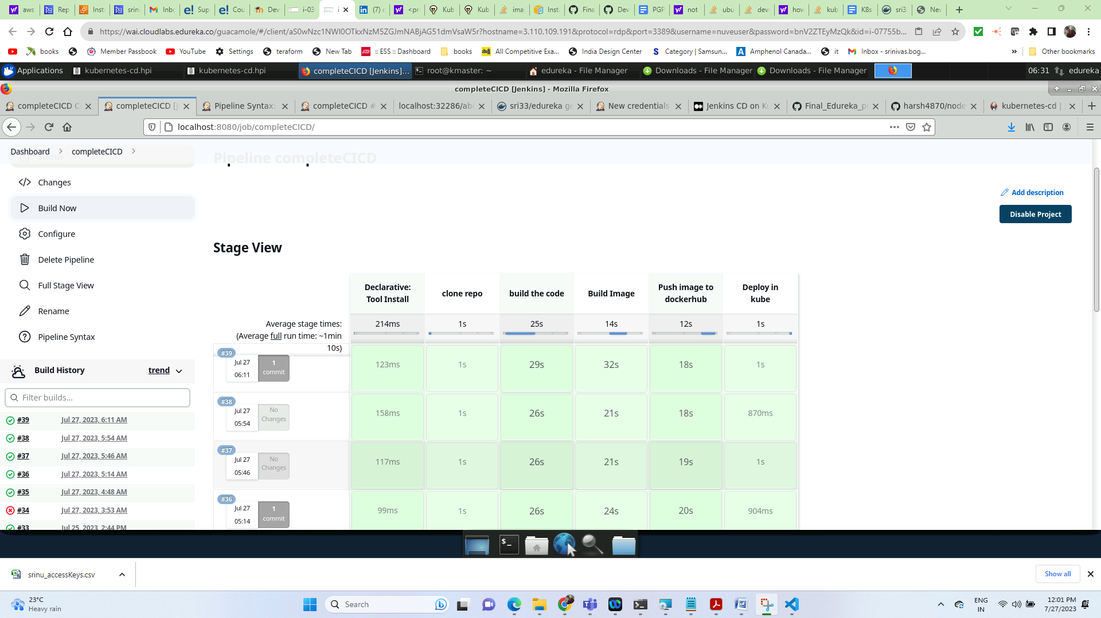

Validating the kubernetes container with service port

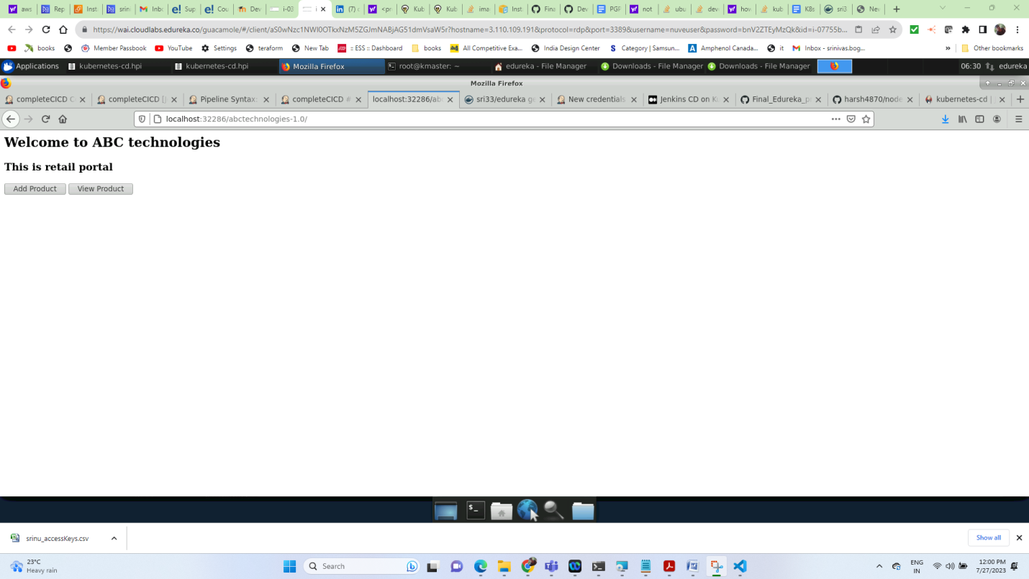

Task 5: Using Prometheus, monitor the resources like CPU utilization: Total Usage, Usage per core, usage breakdown, memory, and network on the instance by providing the endpoints on the local host. Install the node exporter and add the URL to the target in Prometheus. Using this data, log in to Grafana and create a dashboard to show the metrics.

Approach i have followed:

First of all we need to have Prometheus, Grafana but edureka lab already installed these tools. So I had installed the node-exporter in master node to monitor the metrics of a node and added the target url in the prometheus.yml file so that prometheus will start to monitor.

And I have monitored and captured the CPU, memory and network of the target node. And I have created a dashboard by selecting the prometheus app from Grafana and then created a Panel for visualizing the metrics in Grafana.

After installing node exporter I have added the below job in the prometheus.yml file to get the metrics from the target.

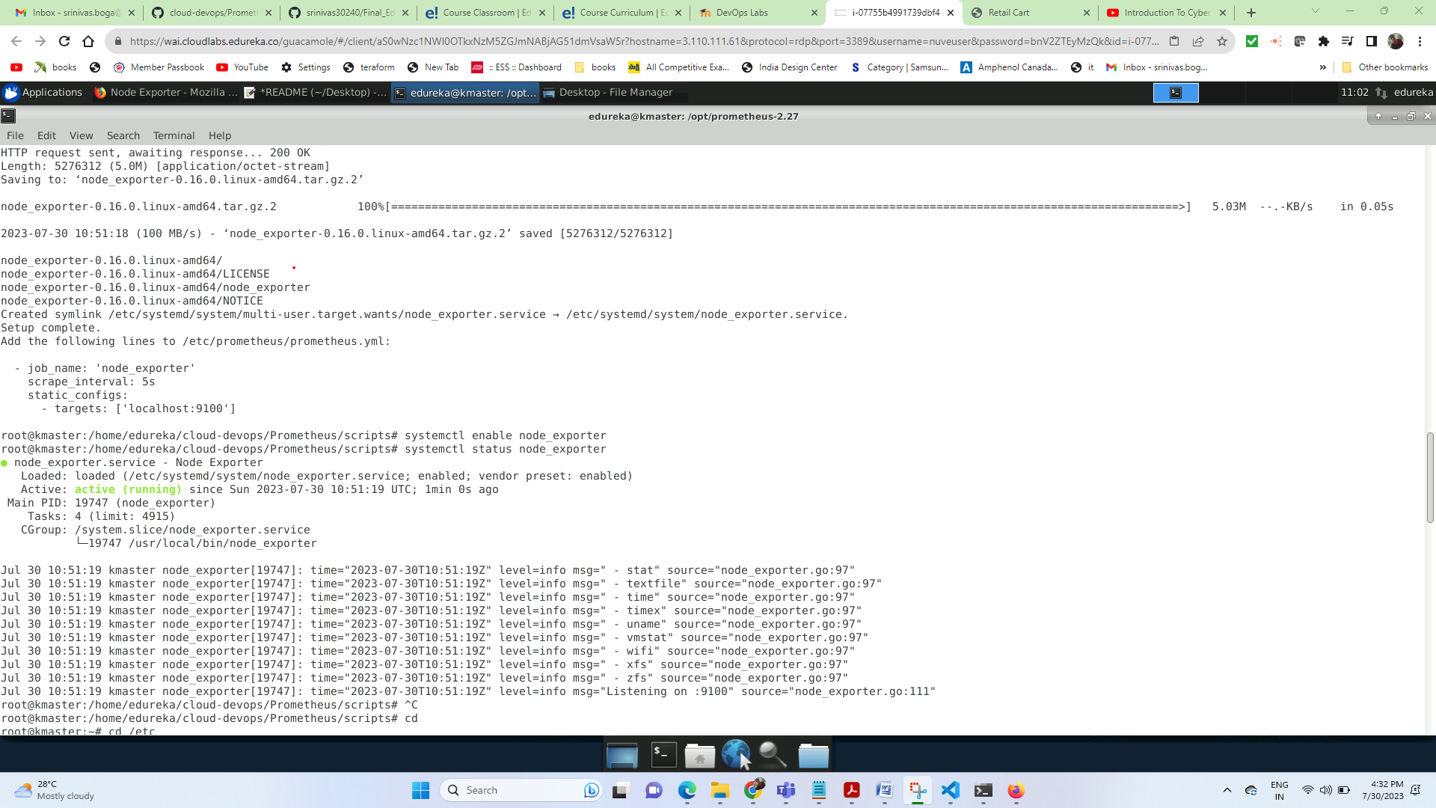

Added job name and target port to **/opt/prometheus-2.27/prometheus.yml**

# my global config global:

scrape_interval: 15s # Set the scrape interval to every 15 seconds. Default is every 1 minute.

evaluation_interval: 15s # Evaluate rules every 15 seconds. The default is every 1 minute.

# scrape_timeout is set to the global default (10s).

# Alertmanager configuration

alerting:

alertmanagers:

- static_configs:

- targets:

# - alertmanager:9093

# Load rules once and periodically evaluate them according to the global 'evaluation_interval'.

rule_files:

# - "first_rules.yml"

# - "second_rules.yml"

# A scrape configuration containing exactly one endpoint to scrape:

# Here it's Prometheus itself.

scrape_configs:

# The job name is added as a label `job=<job_name>` to any timeseries scraped from this config.

- job_name: 'prometheus'

# metrics_path defaults to '/metrics'

# scheme defaults to 'http'.

static_configs:

- targets: ['localhost:9090']

**- job_name: ‘node_exporter’**

**scrape_interval: 5s**

**static_configs:**

**- targets: [‘localhost:9100’]**

**Please find the screenshots:**

**Prometheus self monitoring**

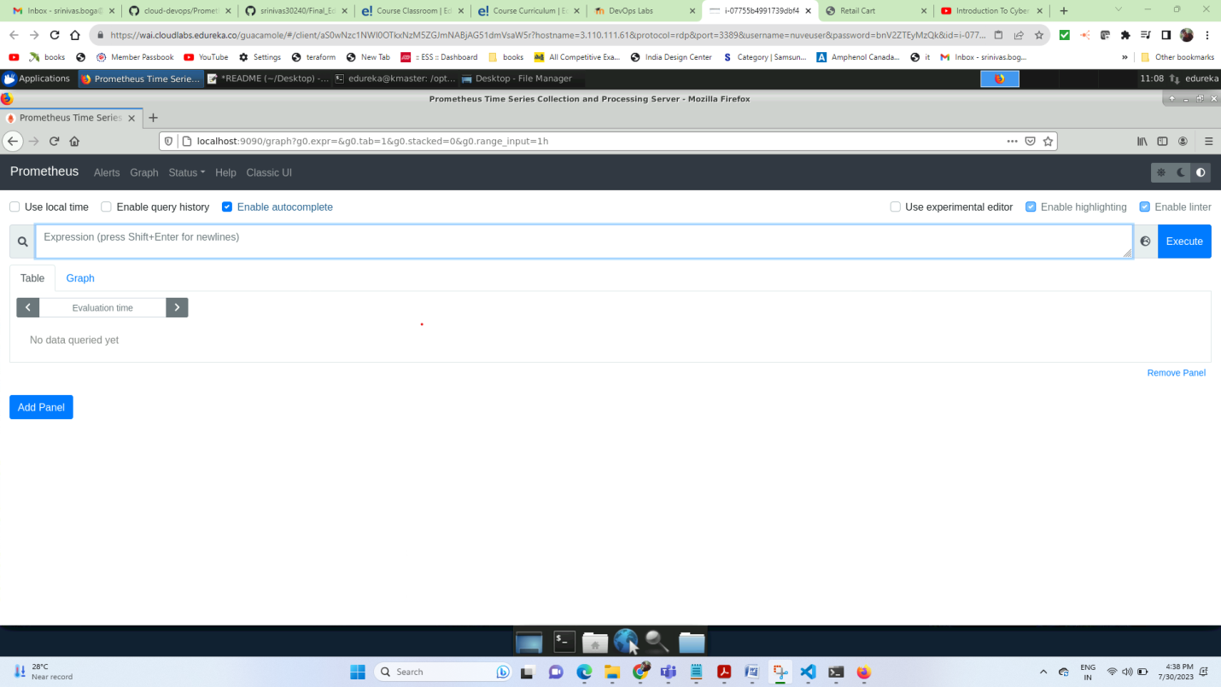

**Graph visualization for the metrics in Prometheus:**

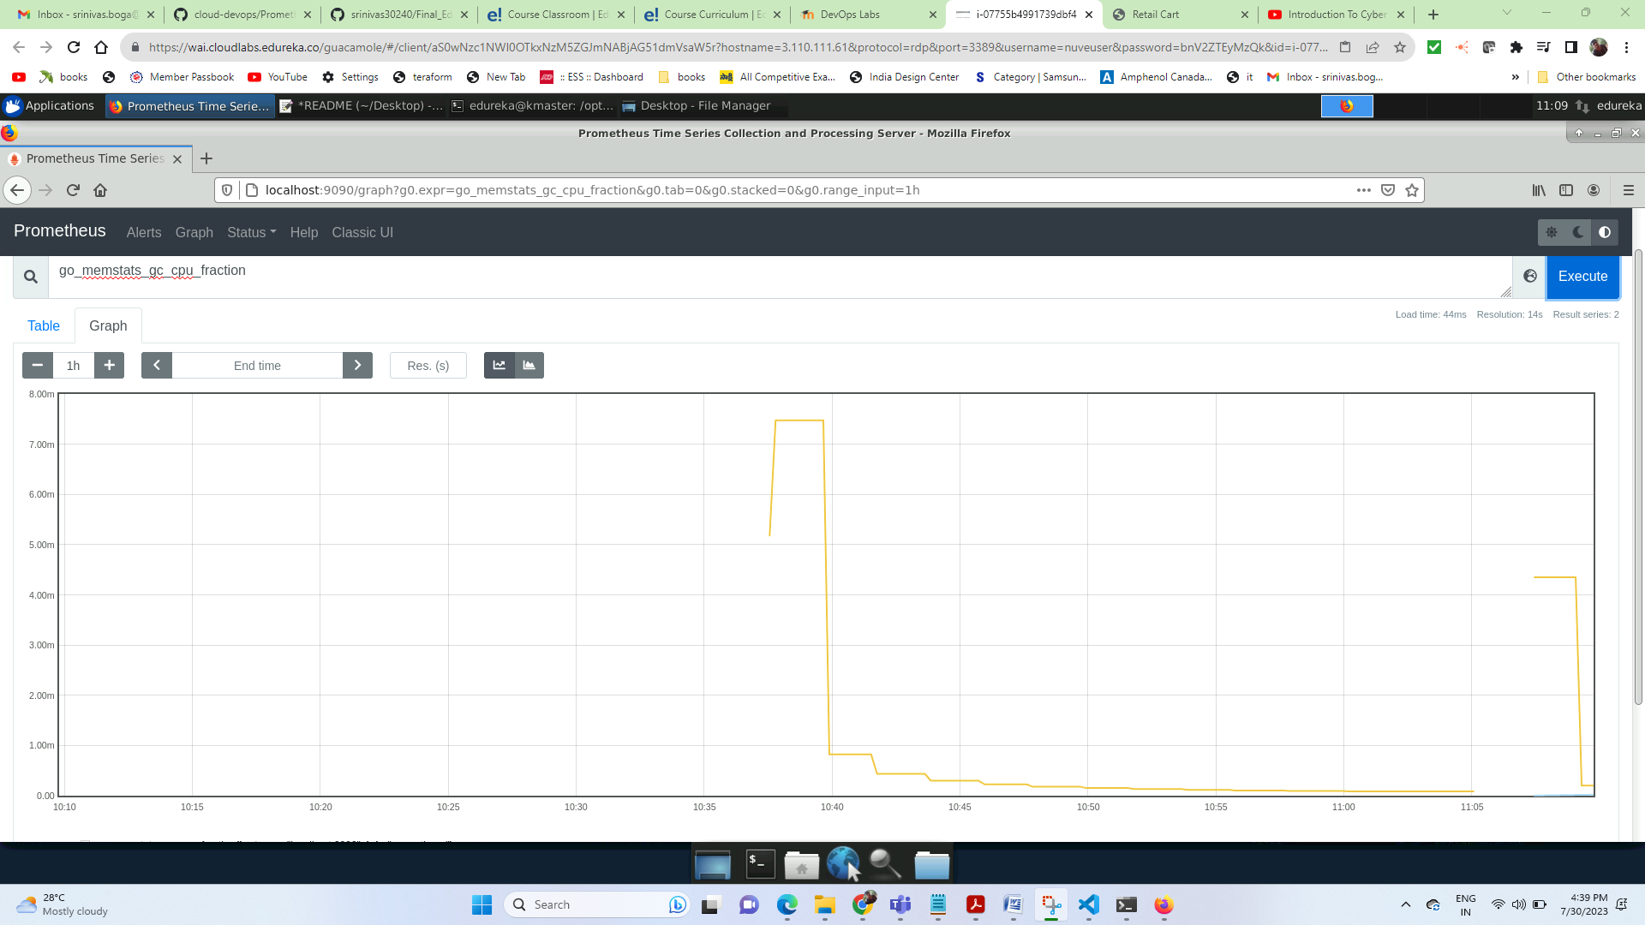

**After adding the node exporter**

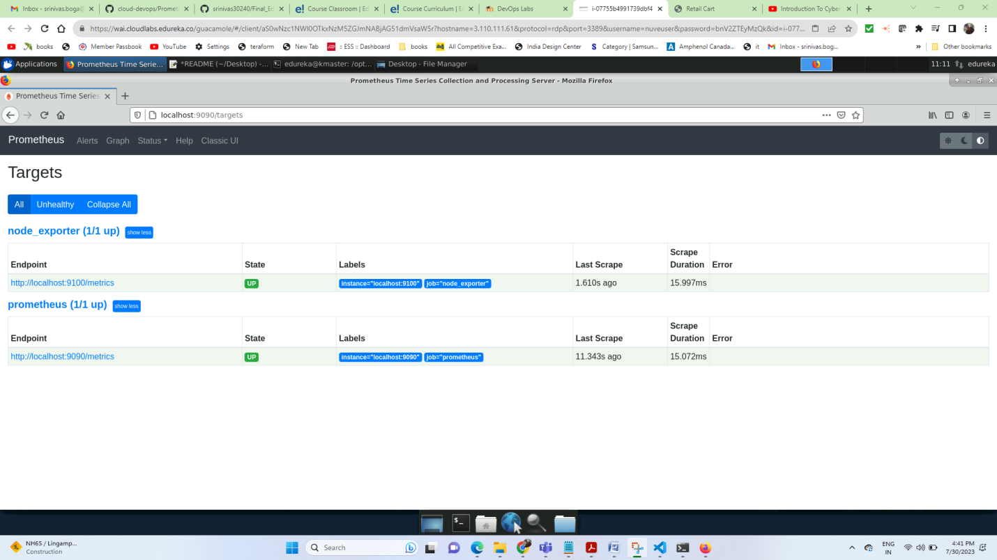

**Alerts tab**

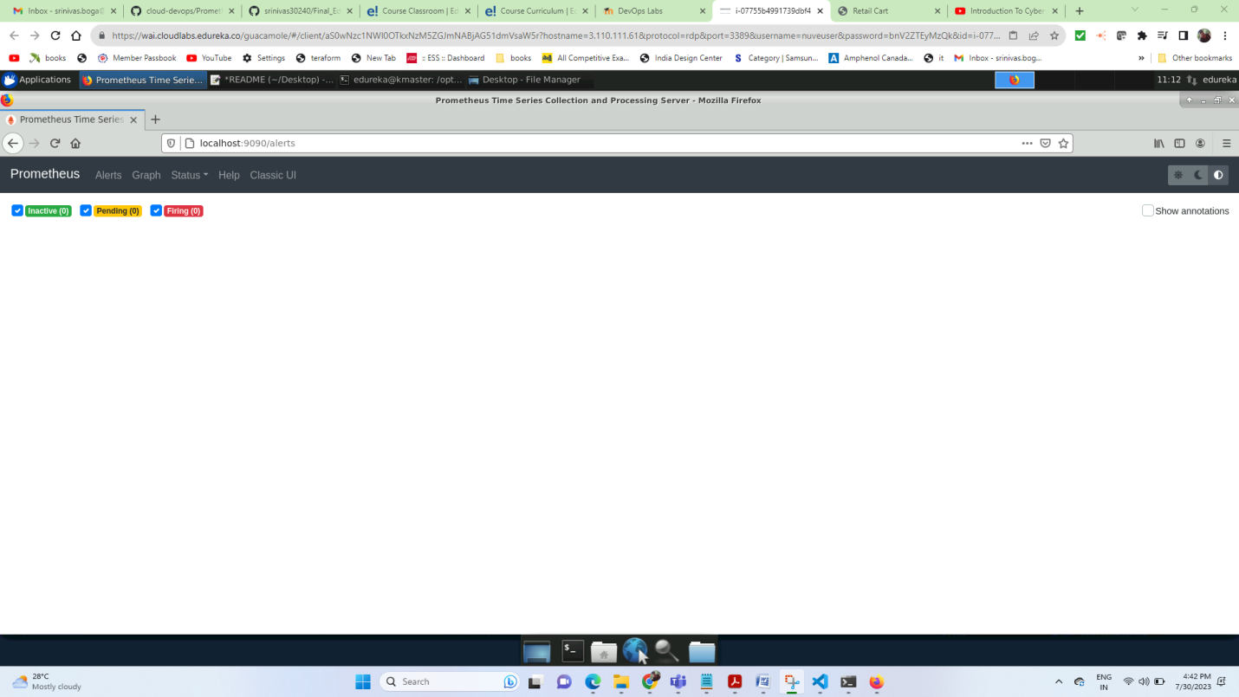

**Node export metric validation**

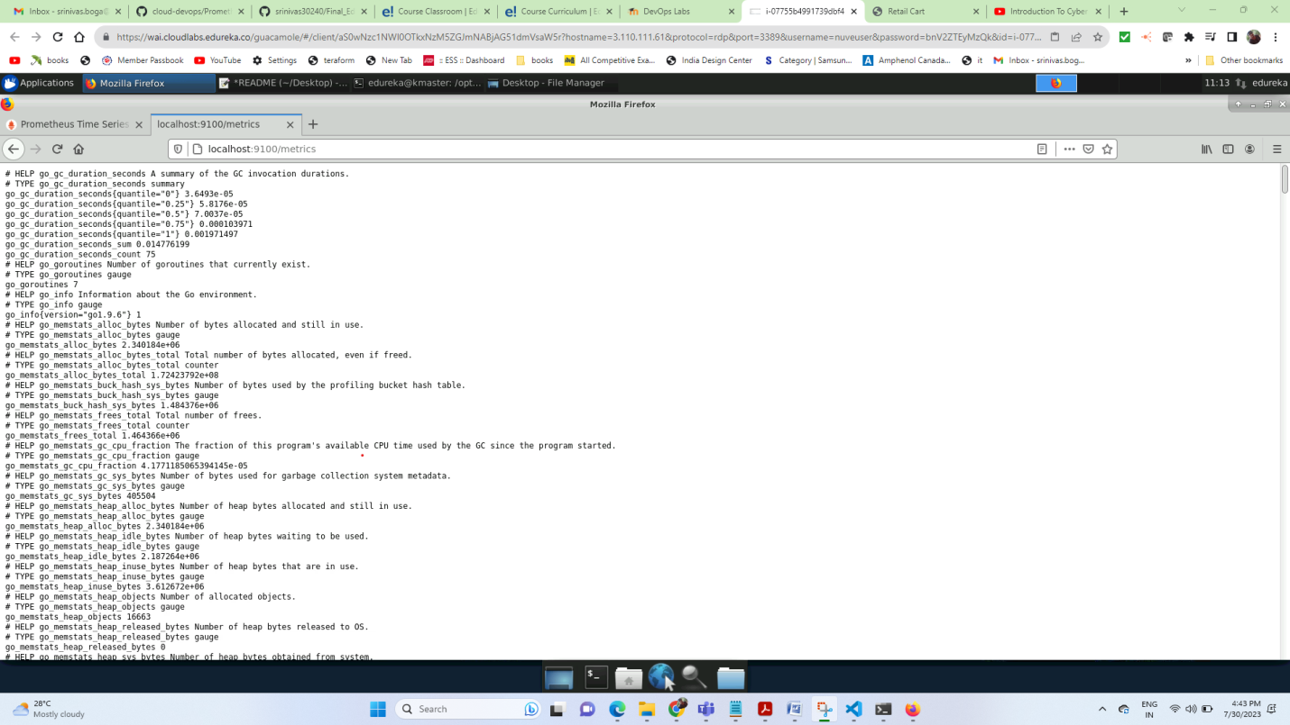

**Node cpu usage total utilization**

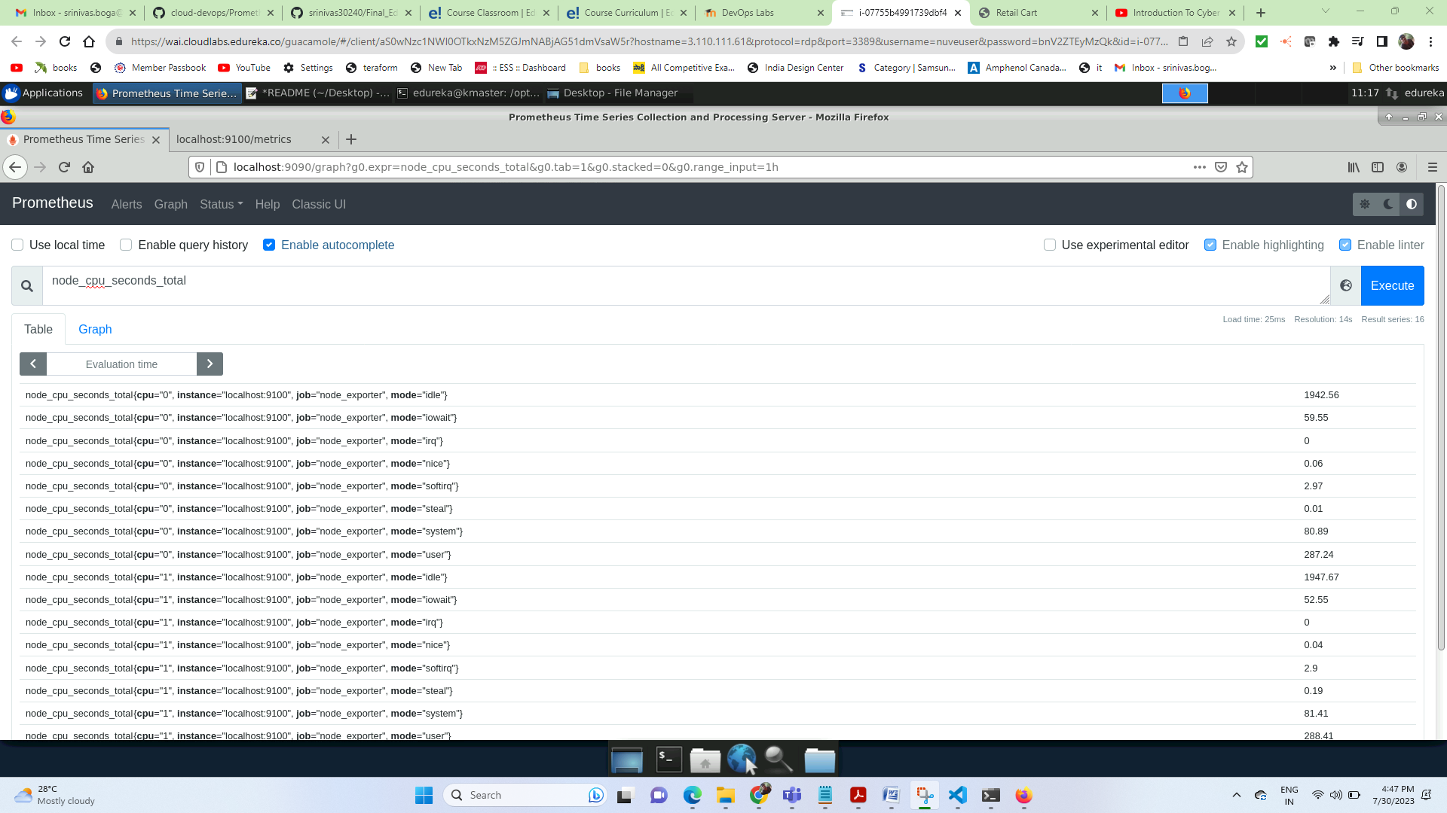

**Total count of cpu usage in seconds from starting**

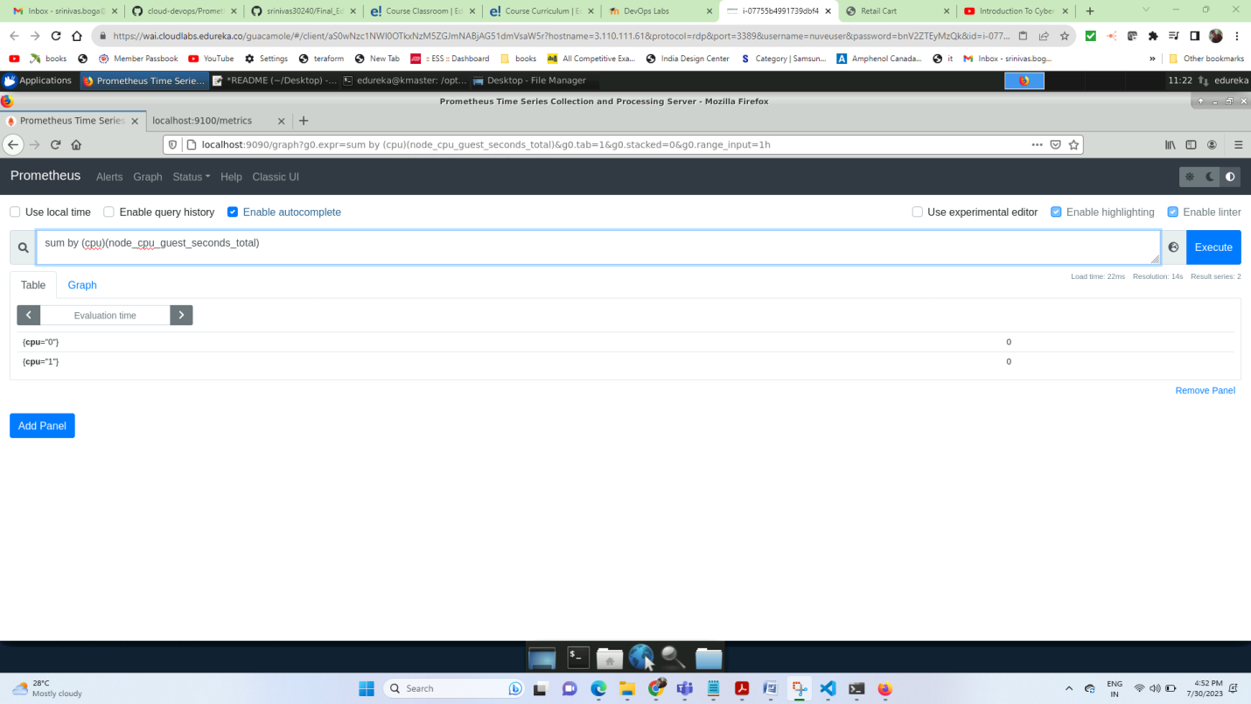

**Total count graph**

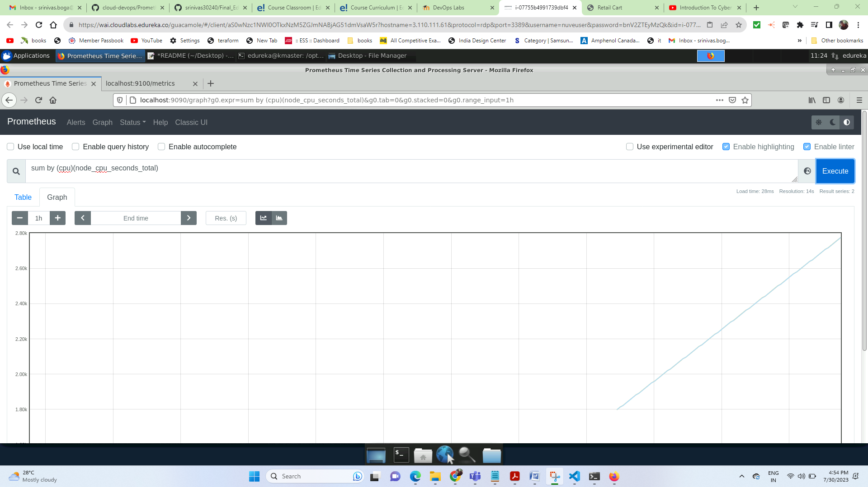

**Rate of growth for cpu in last 5 minutes**

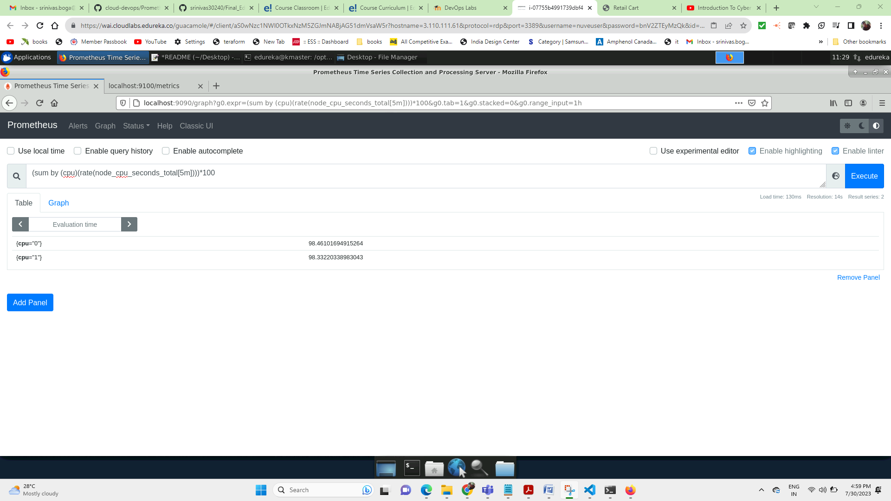

**Graph**

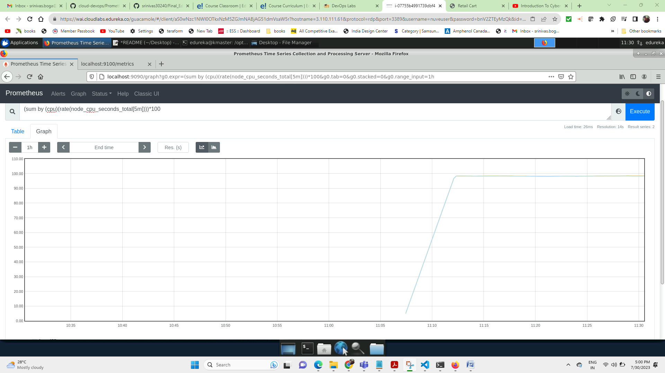

**Cpu utilization:**

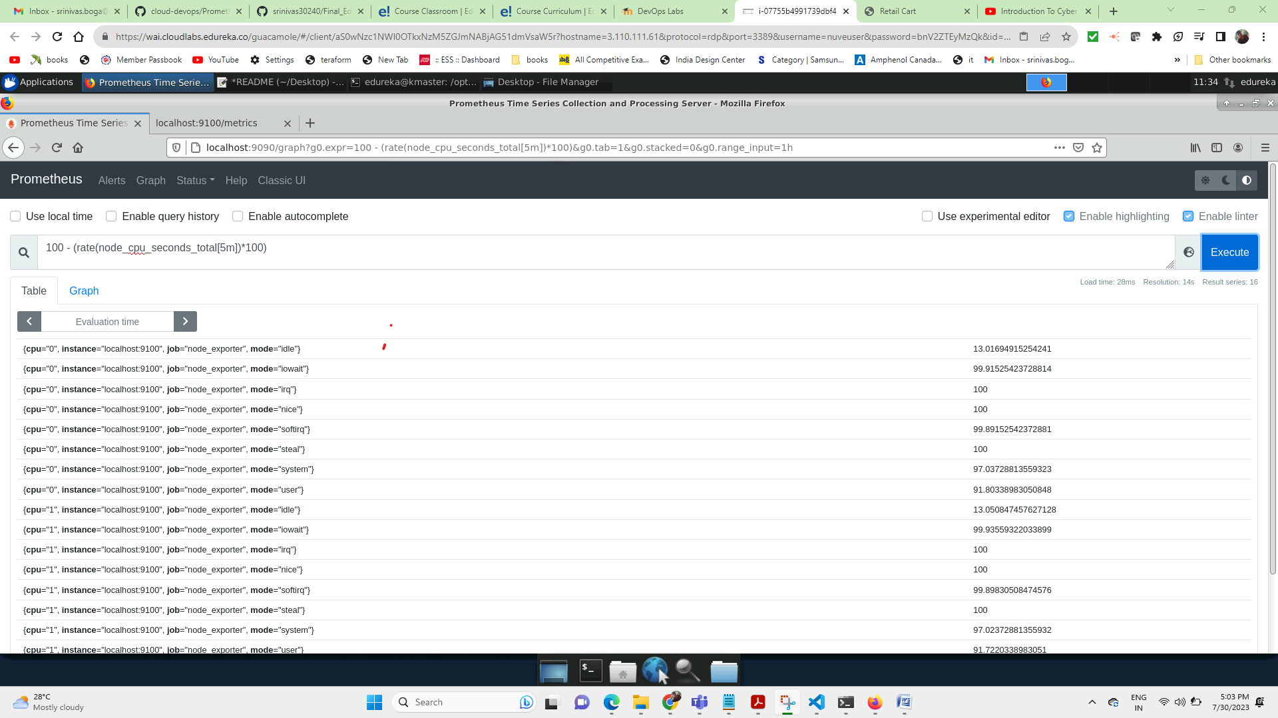

**Graph**

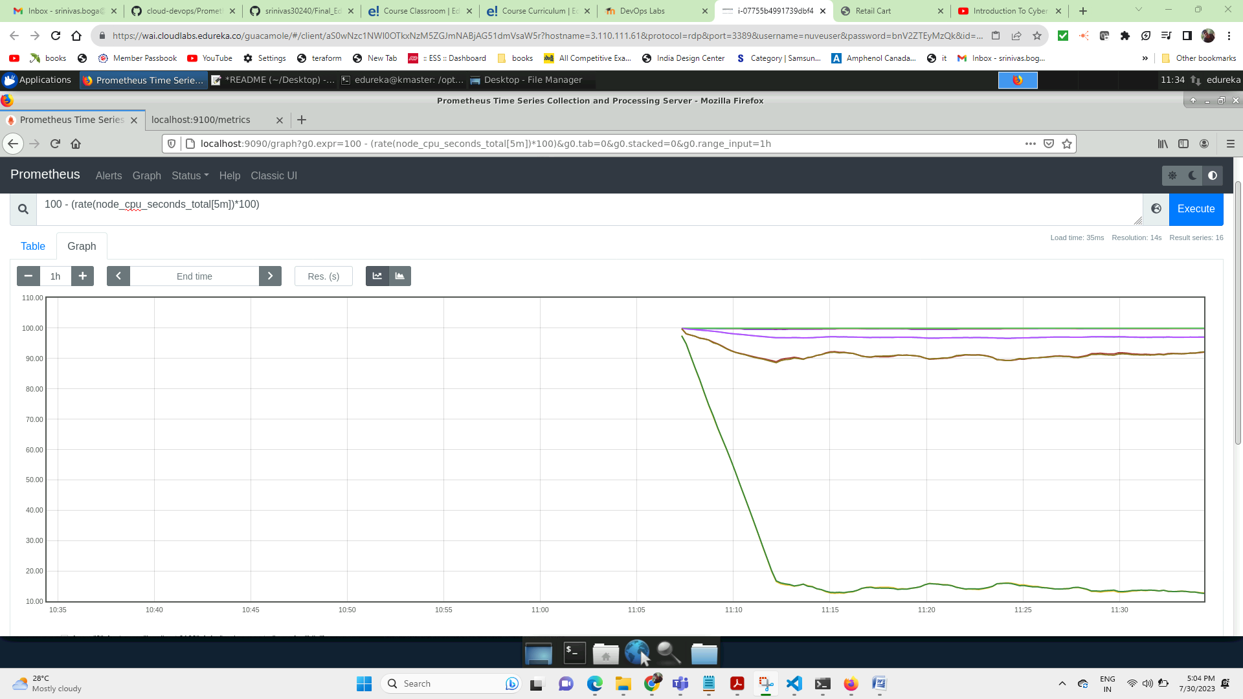

**Memory monitoring:**

**node_memory_MemTotal_bytes:**

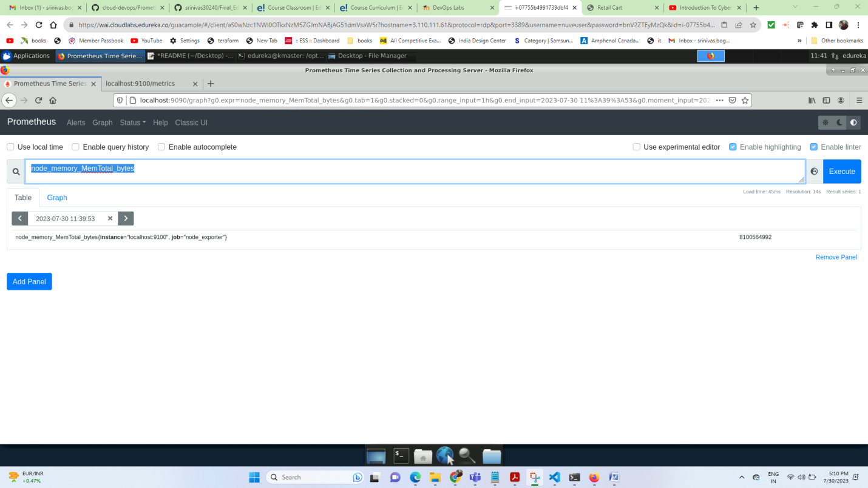

**Graph:**

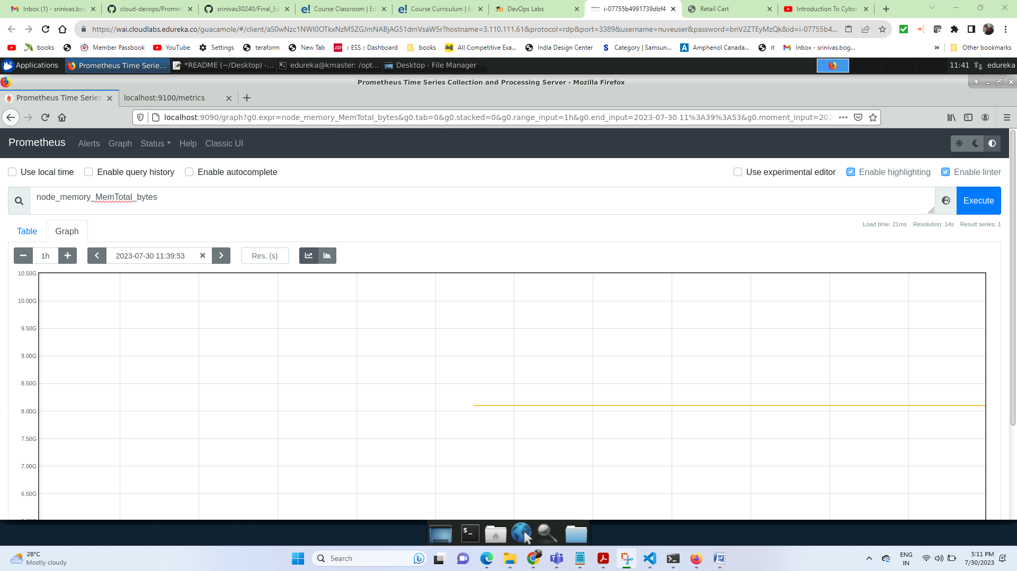

**node_memory_MemAvailable_bytes**

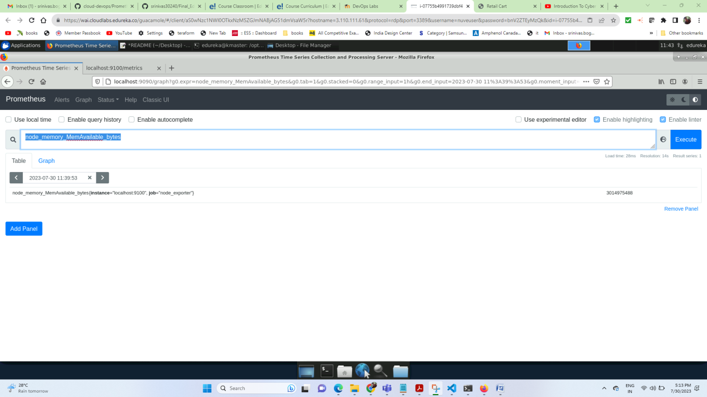

**Graph:**

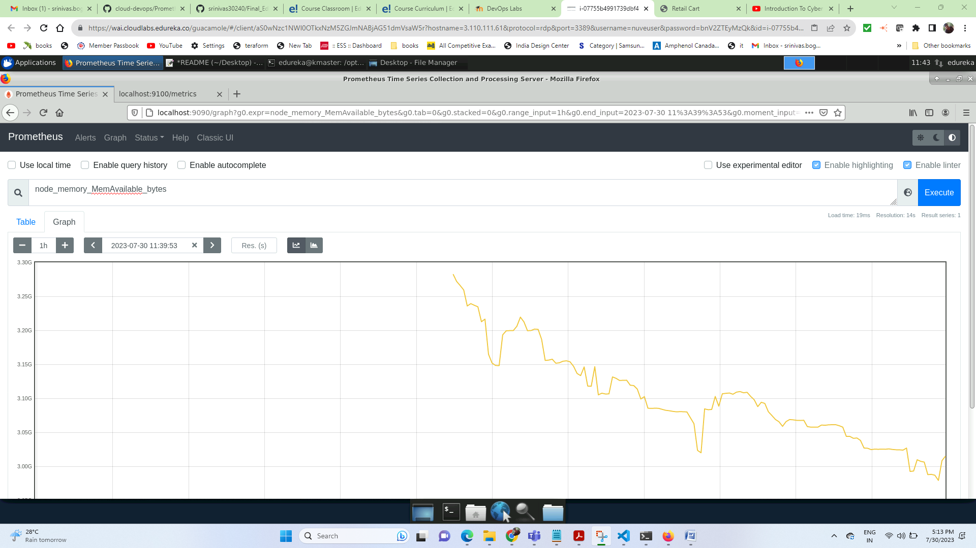

**Node memory available in MB for last 5min**

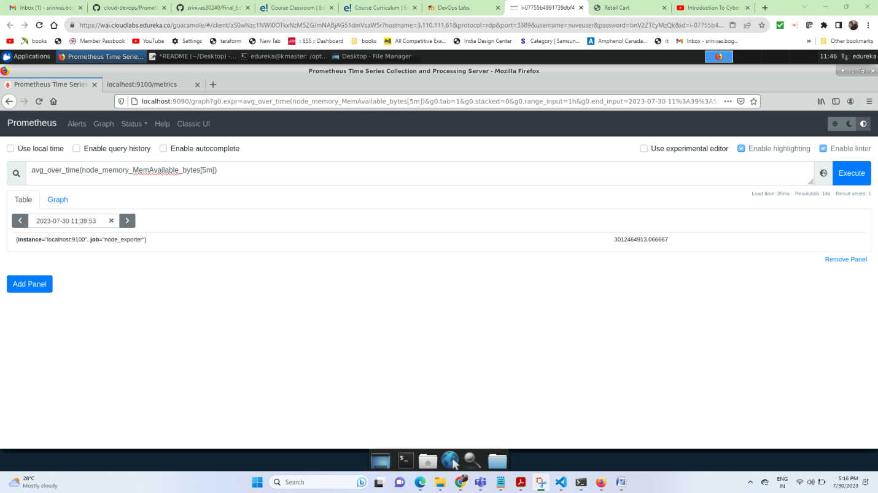

**Graph:**

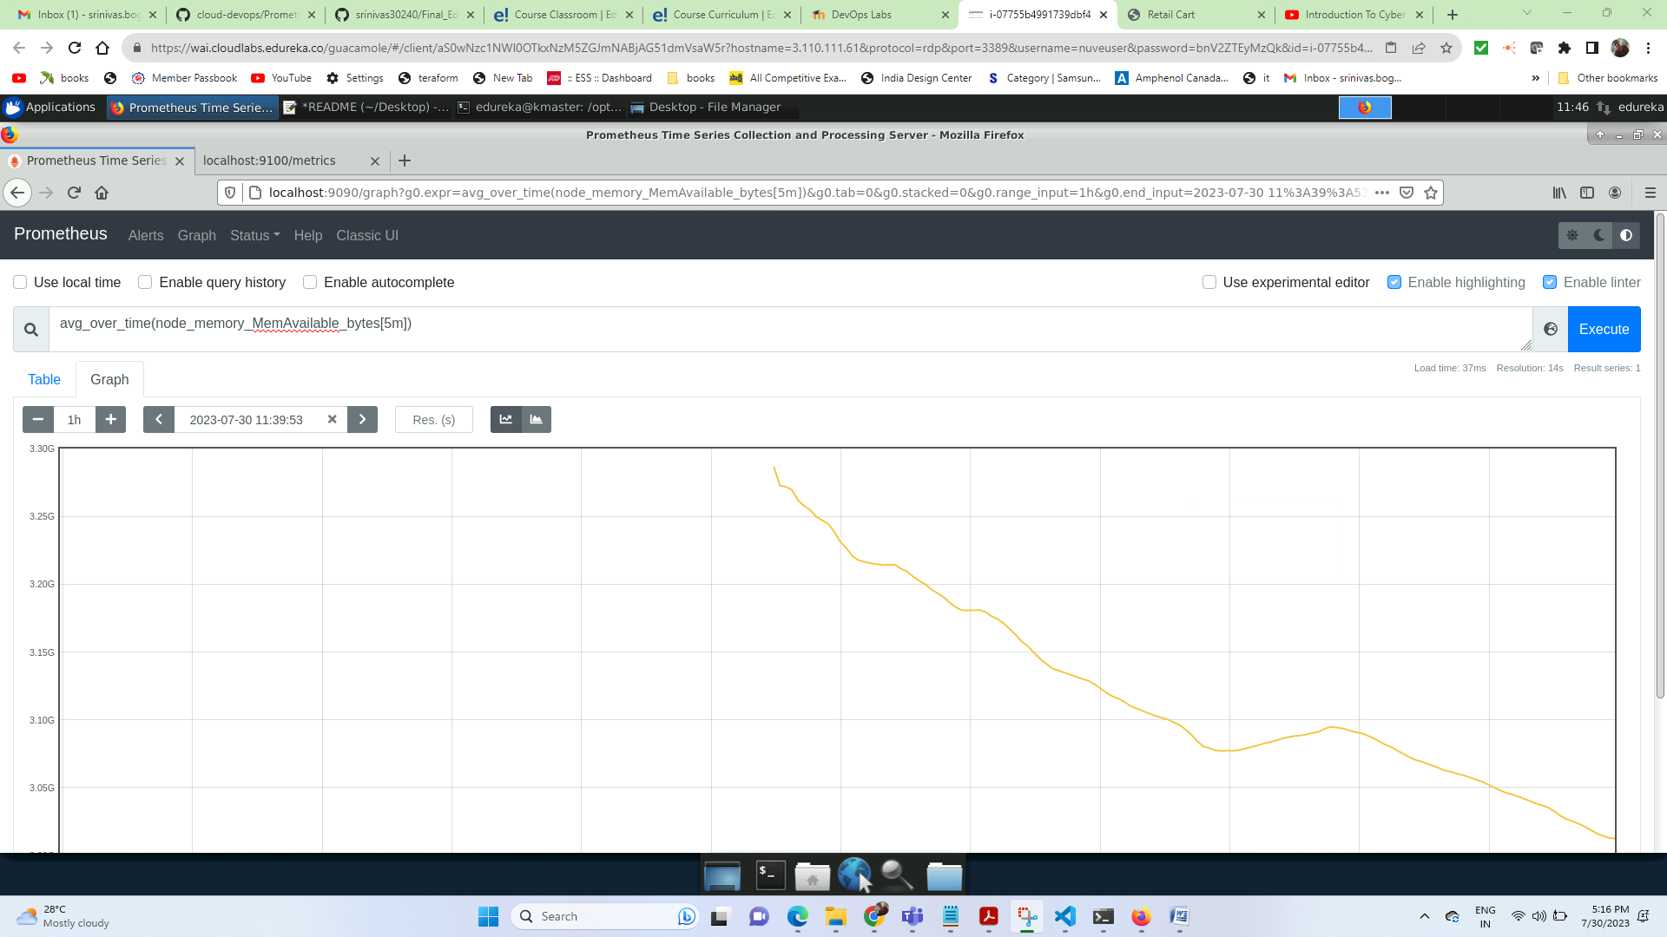

**Networking:**

**node_network_receive_bytes_total**

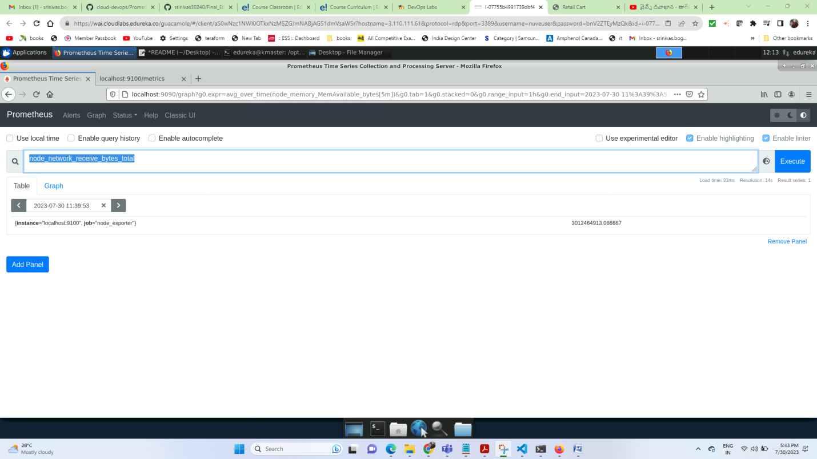

**Graph:**

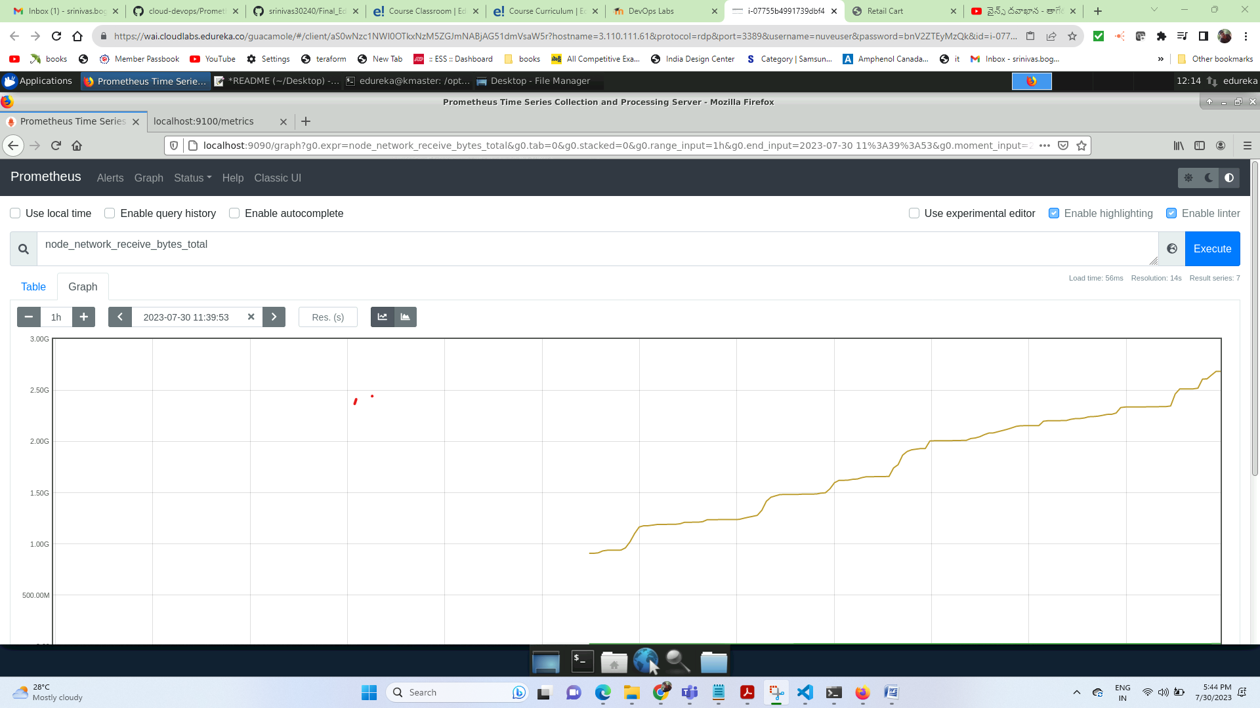

**Grafana**

**Grafana home page:**

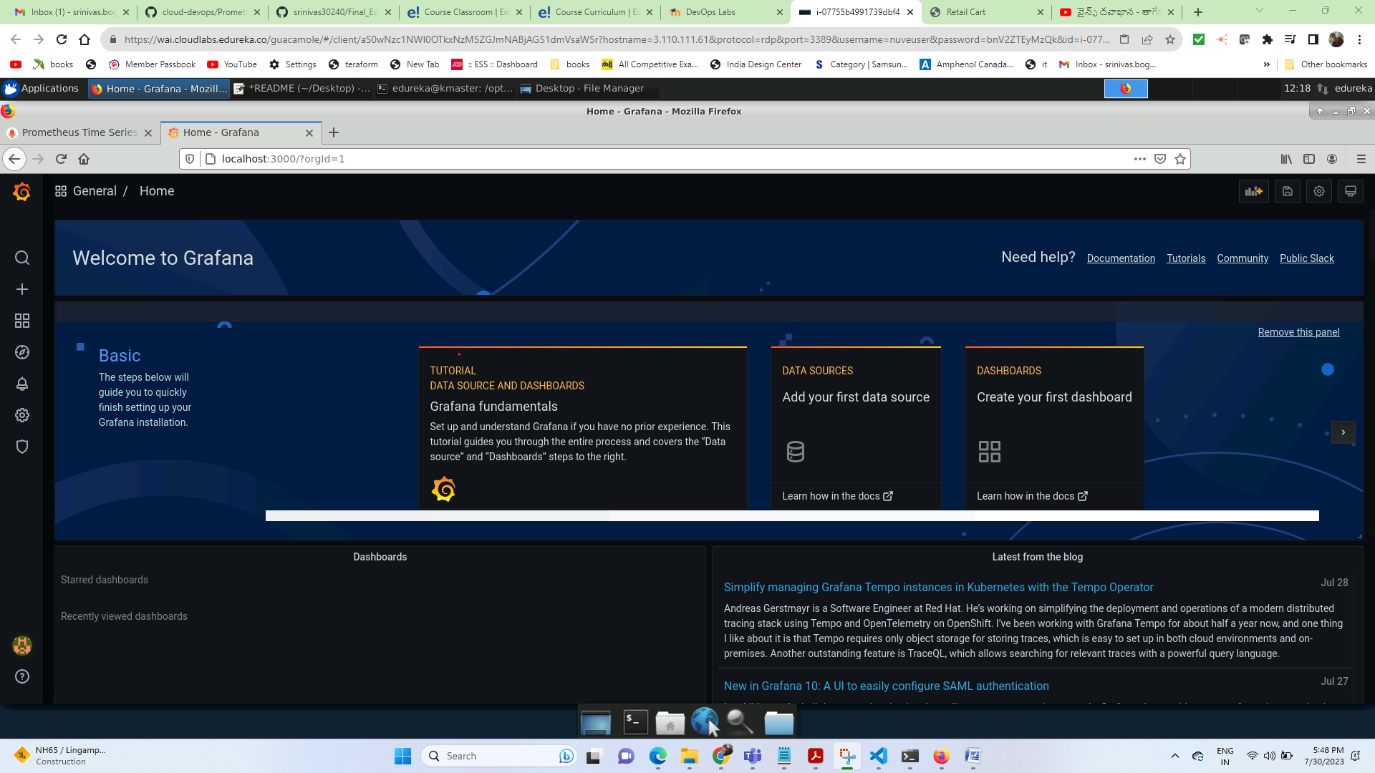

**Setting up the prometheus target:**

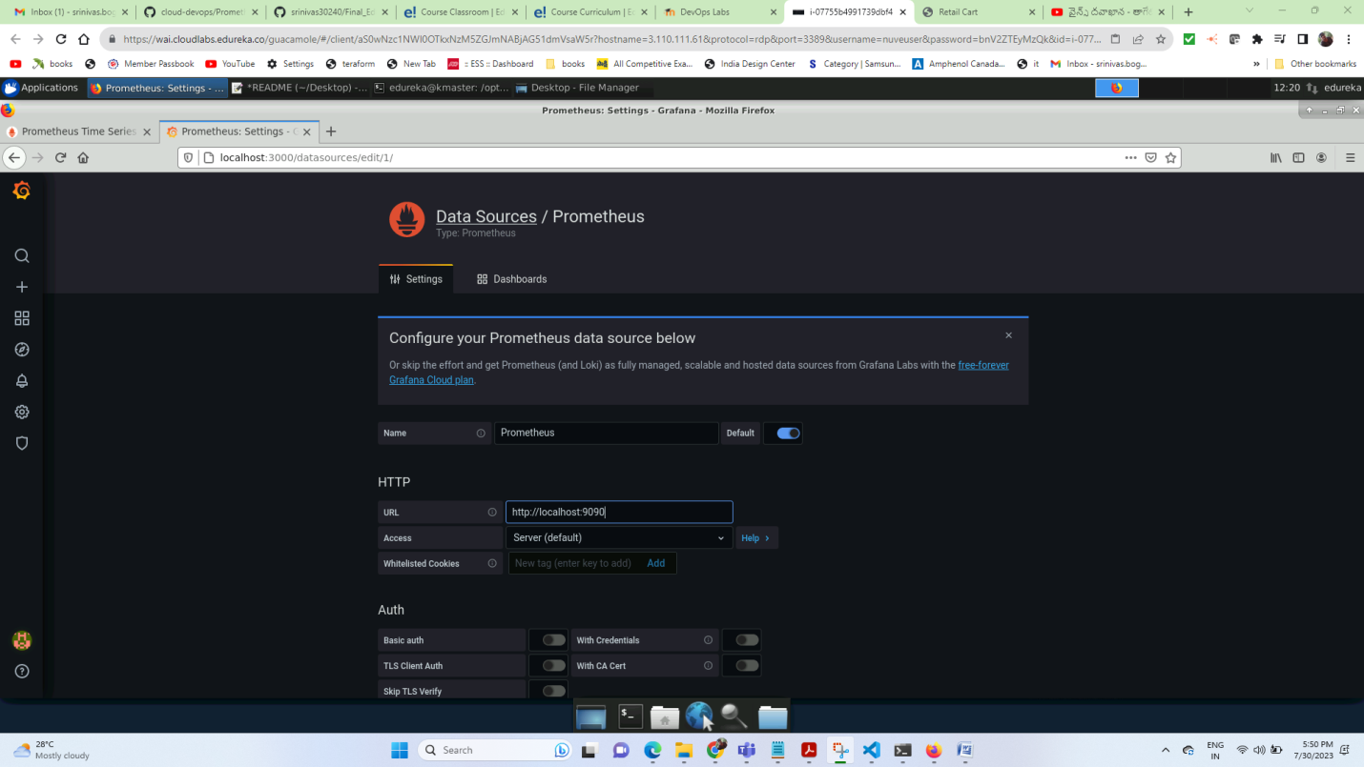

**CPU monitoring**

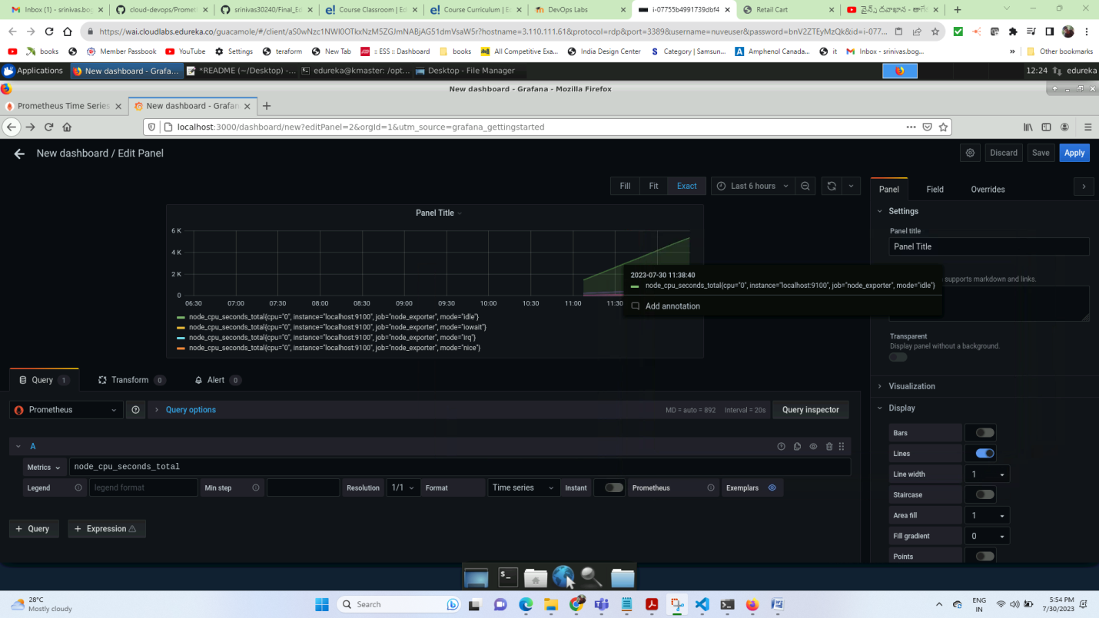

**(sum by (cpu)(rate(node_cpu_seconds_total[5m])))*100**

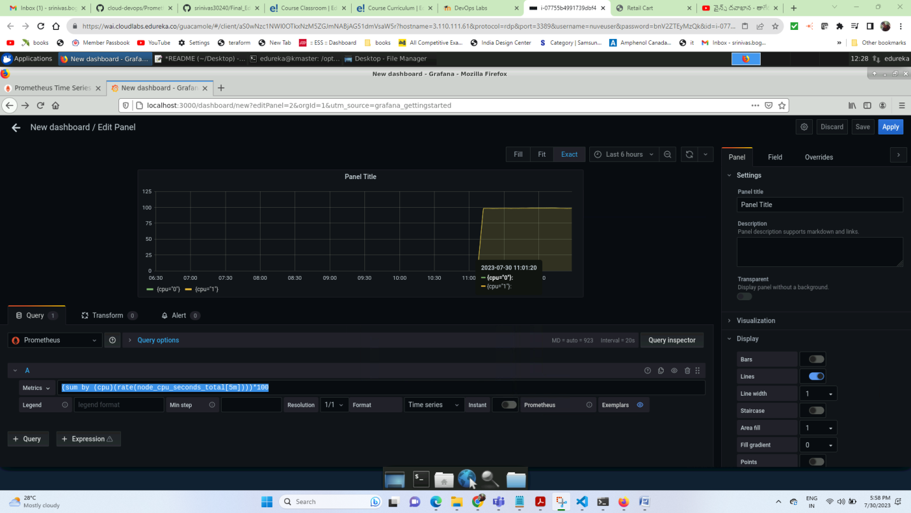

**Memory monitoring**

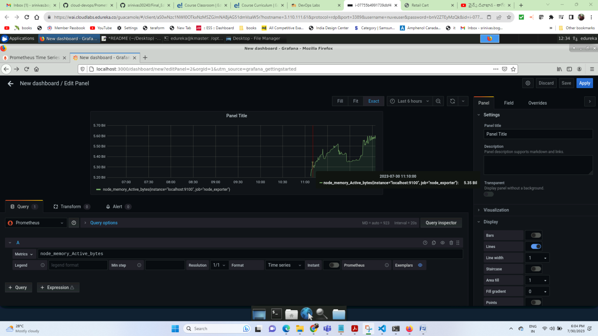

**Network:**

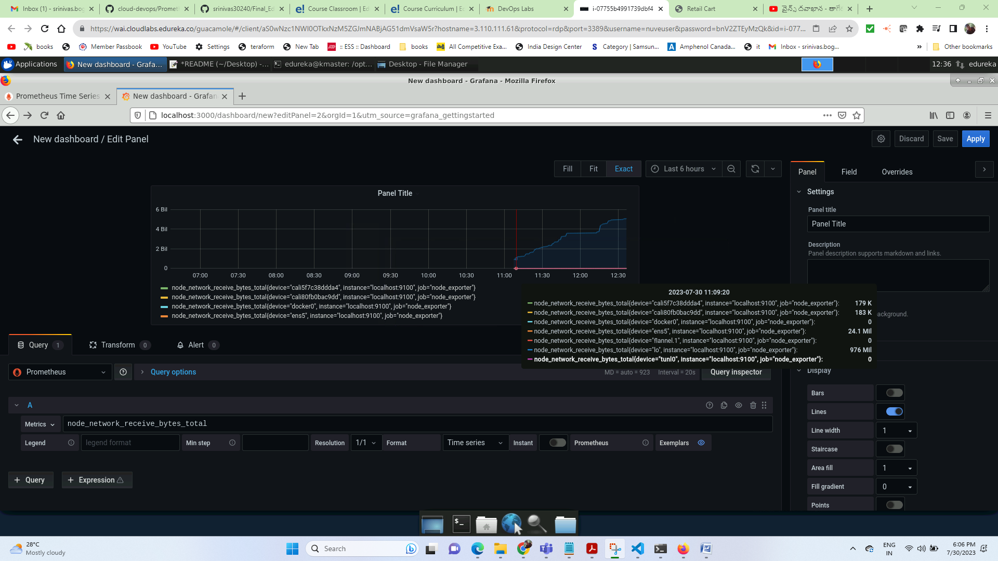

**Thank you**

**Srinivas boga**